Attention - Please Delete This Section After Reading
This section (and all subsequent sections using the Hidden Style) are used for instructional purposes only and should be removed from the document before being published to any stakeholders.

Purpose
This document is to be used to define the business requirements for a long term engagement undertaken by the CCS business. It has been developed to be generic enough to be used for any type of engagements and is not specifically tailored to any one class of project. It should be seen as a starting point and it is expected that the document will be adapted, within limited boundaries, to the specifics of the engagement.

How To Use This Document
For experienced CCS BAs this template and its use will be familiar and this section can be skipped. For new BAs, or those unfamiliar with the template the following guidelines may be helpful.
- When creating a new document from this template always view the document with formatting visible (i.e. click the button in the toolbar). This will ensure all help text (such as this page) is visible.
- Before publishing to stakeholders open Styles and Formatting (under the Format menu), select all instances of text with the Hidden style and delete all occurrences. This will cleanse the document of all hidden instructional text.
- Before adding the engagement specific content ensure that the document properties have been filled out fully (see Properties under the File menu). Ensure, in particular, that all custom properties are filled out correctly.
- Before adding the engagement specific content plan the overall structure of the specification. Throughout the document the instructional text will indicate where a section can be replaced, in entirety by a separate external file due to complexity. These decisions should be made up front to ensure that all published versions of the specification (including initial drafts) have the same breakdown to assist the stakeholders performing document reviews.
- Throughout the document text will appear in angled brackets (e.g. <Title>). In each case these occurrences should be replaced with the correct text specific to the engagement. Note: in some cases these fields will be updated automatically through document properties.

Related Processes
The use of this template is governed by registered PACE processes. Please review these processes before using this template to ensure all conventions are adhered to.

Computershare Communication Services Limited

BMO – US ISO check IMPLEMENTATION

Functional Requirements

Author | Chad Trate
Owner | Rachel Hammond
Reviewer | Kashif Mughni
Version | 1.67
Date | June 29, 2026
File | BMO_ISO_Checks_Functional_Requirement_Document.docx

Owners and List of Contacts
TODO: Ensure any additional contacts that are required are added to this table. Also ensure that the contact phone numbers are made specific for individuals that have direct lines.

Name | Role | Phone
Kashif Mughni | CCS Solutions Manager | 630 568 0232
Mallori Nash | CCS Project Manager | 813 482 6259
Cassandra Bischoff | CCS Business Analyst | 312 207 9682
Chad Trate | CCS Business Analyst | 612 803 4423

Revision History
TODO: Every separate published version of the document requires an entry in this document (including draft versions). As a rule of thumb, the first version should begin with version number 0.01. Subsequent minor changes should be incremented by 0.01. An addition or modification which is considered to be a medium change should be incremented by 0.10. Any major modification to document shoulds be incremented by V1.00.
Please ensure this table is always kept up to date (especially sign off status).

Version | Date | Author | Summary of changes | Approved
1.00 | June 9, 2021 | Anthony Faikus | Initial Draft | N/A
1.01 | July 6, 2021 | Anthony Faikus | Updated: R21310, R23140, R24585, Appendix A  Added: R24212, R24220, R24230, R24232, R24234, R24236, R24240, R24242, R24244, Section 2.5.2.1, Section 2.5.2.2, R25310, R25312, R25314, R25320, R25322, R25324, R25330, R25332, R25334, R25340, R25342  Removed: Section 2.7.1
1.02 | July 13, 2021 | Anthony Faikus | Per feedback:  Added: R24222, R24237, R24238, R24245, R24246, R24412, R24512, R24532, R24533, R24534, R24535, Section 2.4.7 Duplicate Check Database, Section 2.4.8 File Consolidation, Appendix C  Updated: R21310, R23140, R24212, R24213, R24214, R24236, R24244, R24510, R24511, R24610, R25210, R25312, R25322, R25332, Appendix A, Appendix B  Removed: Section 2.4.7 Document Composition Failure
1.03 | July 22, 2021 | Anthony Faikus | Per feedback:  Updated: R21310, R23135, R23140, R24210, R24220, R24222, R24224, R24230, R24232, R24240, R24242, R24246, R24720, R24760, R24820, R25120, R25310, R25312, R25314, R25320, R25322, R25324, R25330, R25332, R25334, R25340, R25350, R25410, R25470, Appendix A  Added: R23150, R23152, R23154, R23156, R23158, Section 2.4.9, R25342, R25352, R25480  Removed: R24211, R25440
1.04 | July 22, 2021 | Anthony Faikus | Per feedback:  Updated: R21310, R23140, R23154, R24210, R24246, R24960, R25332, R25411
1.05 | August 4, 2021 | Anthony Faikus | Per feedback:  Updated: R23154, R23156, R23158, R24511, R24532, R25212, Appendix A  Removed: R24512, R24533, Section 2.6.2, Section 2.6.3
1.06 | August 10, 2021 | Anthony Faikus | Per feedback:  Updated: R21310, R23140, R252110, R252140, Appendix A  Added: R252115
1.07 | August 13, 2021 | Anthony Faikus | Per feedback:  Added: R24226, R24228, R24234, R24236, R24246, R24248, R25454, R25456  Updated: R24210, R24224, R24232, R24244, R24250, R24252, R24340, R25120, Appendix A  Removed: R24222, R24242
1.08 | August 17, 2021 | Anthony Faikus | Per feedback:  Added: R24212, R24587
1.09 | August 20, 2021 | Anthony Faikus | Per feedback:  Updated: Section 2.5.2.2, Appendix A
1.10 | August 31, 2021 | Anthony Faikus | Per feedback:  Updated: R21310, R24210, R24232, R24234, R24236, R24252, R24254, R24256, R24830, R252120, R252130, Appendix A  Added: R24211  Removed: R24226
1.11 | September 1, 2021 | Anthony Faikus | Per feedback:  Updated: R24211, Appendix A
1.12 | September 2, 2021 | Anthony Faikus | Per feedback:  Updated: R24252, R25454, R25456, Appendix A
1.13 | September 7, 2021 | Anthony Faikus | Per feedback:  Removed: R24246
1.14 | September 10, 2021 | Anthony Faikus | Per feedback:  Updated: R24224, R24228, R24244, R24248, R24585, R24610, Appendix A  Added: R24226, R24246  Removed: R24950
1.15 | September 16, 2021 | Anthony Faikus | Per feedback:  Updated: R25150
1.16 | September 21, 2021 | Anthony Faikus | Per feedback:  Updated: R25150, R252120, R252140  Removed: R252130
1.17 | September 23, 2021 | Anthony Faikus | Per feedback:  Updated: R24252, R24254, R24256
1.18 | September 24, 2021 | Anthony Faikus | Per feedback:  Updated: R25150
1.19 | September 28, 2021 | Anthony Faikus | Per feedback:  Updated: R25150, R252120, R25312
1.20 | September 30, 2021 | Anthony Faikus | Per feedback:  Updated: R25150, R25342, R25350
1.21 | October 14, 2021 | Anthony Faikus | Per feedback:  Updated: R24740, R24760, R252120, R25312, R25322
1.22 | November 10, 2021 | Anthony Faikus | Per feedback:  Updated: R25150, Appendix A
1.23 | June 28, 2022 | Anthony Faikus | Per BMO Request:  Updated: R23140
1.24 | July 20, 2022 | Cassandra Bischoff | Per BMO Request:  Updated: Appendix A
1.25 | September 21, 2022 | Cassandra Bischoff | Per BMO Request:  Added: R25131, R25132  Updated: R25150
1.26 | October 19-26, 2022 | Charlie Harper | Added: Section 2.5.2.3  Updated: R24610
1.27 | November 11, 2022 | Cassandra Bischoff | Per BMO Request  Added: R25133, R25353  Updated: R21310, R24210, R24720, R24760, R25130, R25131, R25132, R25140
1.28 | November 15, 2022 | Cassandra Bischoff | Added: R24588  Updated: Appendix A, Check Details section
1.29 | January 9, 2023 | Cassandra Bischoff | Updated: Appendix A, Check Details section, MemoFld
1.3 | February 6, 2023 | Cassandra Bischoff | Updated: R25150; R25314
1.31 | February 21, 2023 | Cassandra Bischoff | Removed: R24210, R25132, R25133, R25470, & R25471  Added: R24321, R25412, R25413, R25490, R25491, R25492, & Appendix D  Updated: R24210,R24720, R24760, R25130, R25140, R25150, R25410, R25411, & R25480
1.32 | April 20, 2023 | Cassandra Bischoff | Updated: R25150 & Appendix D
1.33 | April 25, 2023 | Cassandra Bischoff | Updated: R23140, R23154
1.34 | May 1, 2023 | Cassandra Bischoff | Removed: R25130  Updated: R25140, R25490, Appendix D
1.35 | May 31, 2023 | Cassandra Bischoff | Added: R24531.2, R24531.3
1.36 | June 12, 2023 | Cassandra Bischoff | Removed: R24531.3  Updated: R23140, R252115, R252120, & R252140
1.37 | June 16, 2023 | Cassandra Bischoff | Added: R24531.4
1.38 | June 23, 2023 | Cassandra Bischoff | Updated: R24720
1.39 | June 27, 2023 | Cassandra Bischoff | Added: R24721
1.40 | August 1, 2023 | Charles Harper | Updated: R24610, R25310, R252330
1.41 | August 3, 2023 | Cassandra Bischoff | Updated: R24610
1.42 | August 24, 2023 | Cassandra Bischoff | Updated: R252310
1.43 | August 31, 2023 | Cassandra Bischoff | Updated: R252330
1.44 | September 5, 2023 | Cassandra Bischoff | Updated: R24610, R252330
1.45 | October 25, 2023 | Cassandra Bischoff | Updated: R23140  Added: R23160, R23165, R23170, R23175, R23180
1.46 | November 8, 2023 | Cassandra Bischoff | Updated: R24234, R24254, Appendices A, B, C & D  Added: R24420 & R24430
1.47 | November 20, 2023 | Cassandra Bischoff | Updated: R23165, R23170, R23175  Removed: R23175, R23180
1.48 | November 28, 2023 | Cassandra Bischoff | Updated: R23160, R23165
1.49 | December 6, 2023 | Cassandra Bischoff | Updated: R23160, R23165, Appendix A
1.50 | December 12, 2023 | Cassandra Bischoff | Updated: R252140
1.51 | February 7, 2024 | Cassandra Bischoff | Updated: R23160
1.52 | February 7, 2024 | Bryan  Rauda | Updated R23140, R24340, R24580, appendix a,  Added R24581, R24582,R24583, R24584, R24585, R24586, R27000, R27001
1.53 | February 8, 2024 | Bryan  Rauda | Updated R24586, and Appendix A
1.54 | February 27, 2024 | Bryan Rauda | Updated R24586
1.55 | March 5, 2024 | Bryan Rauda | Updated R25120
1.56 | April 19, 2024 | Anna Kroczak | WR577. Updated R25320
1.57 | April 22, 2024 | Anna Kroczak | WR577. Updated: R25312
1.58 | April 24, 2024 | Anna Kroczak | WR577. Updated: R25332
1.59 | April 30, 2024 | Anna Kroczak | WR577. Updated: R25332, R25322
1.60 | May 3, 2024 | Anna Kroczak | WR599. Updated: R252330
1.61 | May 15, 2024 | Anna Kroczak | WR577. Updated: R25312, R25322
1.62 | May 22, 2024 | Anna Kroczak | WR577. Updated: R25332  WR569: Updated: R23140
1.63 | July 15, 2024 | Arulini Rajmohan | WR608  Updated  R24212 – FRD update only (verified no changes to code)  R24232, R24234 & R24236 – Service code update to 1DA for Special Handling code 01 & 03)  Added  R24222 – UPS BULK Address Sheet per package  R24242 – FEDEX BULK Address Sheet per package
1.64 | September 5, 2024 | Anna Kroczak | Added R25492  Updated R25411, R25413, R25491.  Deleted R25492
1.65 | May 28, 2025 | Bryan Rauda | Added R27002., R27003, and R27004
1.66 | August 12, 2025 | Bryan Rauda | Updated R24583, R24584, R245855, R24586
1.67 | June 29th, 2026 | Chad Trate | -Added Mockup to Appendix B  -Updated R27001 to include new table type  -Added R24591 to describe new table mapping  -Added R24592 to show new table segment  -Updated R25120 with new acknowledgement naming convention  -Updated R24340 with new file naming convention  -Updated R27000 with information box update

Table of Contents
1 Project Overview 1
1.1 Overview 1
1.2 Intended Audience 1
1.3 Project Overview 1
1.4 Solution Design Considerations 1
1.5 Assumptions 1
1.6 Reference Documents 1
2 Technical Requirements 2
2.1 Aardvark Contract 2
2.1.1 Aardvark Contract Setup 2
2.1.2 Aardvark Contract Job Bag 2
2.1.3 Aardvark Job Bag Stream Setup 2
2.2 FTP File Transfer 4
2.3 enCompass 2 5
2.3.1 enCompass 2 Requirements 5
2.4 Programming Requirements 8
2.4.1 Programming Pre-requisites 8
2.4.2 Streaming Logic 8
2.4.3 File Specifications 21
2.4.4 Client File to PO File mapping 21
2.4.5 Complex Segments 23
2.4.6 Set Tags 33
2.4.7 Duplicate Check Database 33
2.4.8 File Consolidation 34
2.4.9 Production Control Elements 34
2.5 Reporting 35
2.5.1 Acknowledgement 35
2.5.2 BMO Reports 38
2.5.2.1 Positive Pay Report 38
2.5.2.2 Deleted Section 40
2.5.2.3 Monthly Billing Report 40
2.5.3 Client Reports 42
2.5.4 Error Reporting 45
2.6 Publisher Online Configuration 47
2.6.1 Context 47
2.7 Publisher Online Document Composition 47
Appendix A – BMO/PO Data Mapping 49
Appendix B – Mockup 54
Appendix C – Mockup with PO Mappings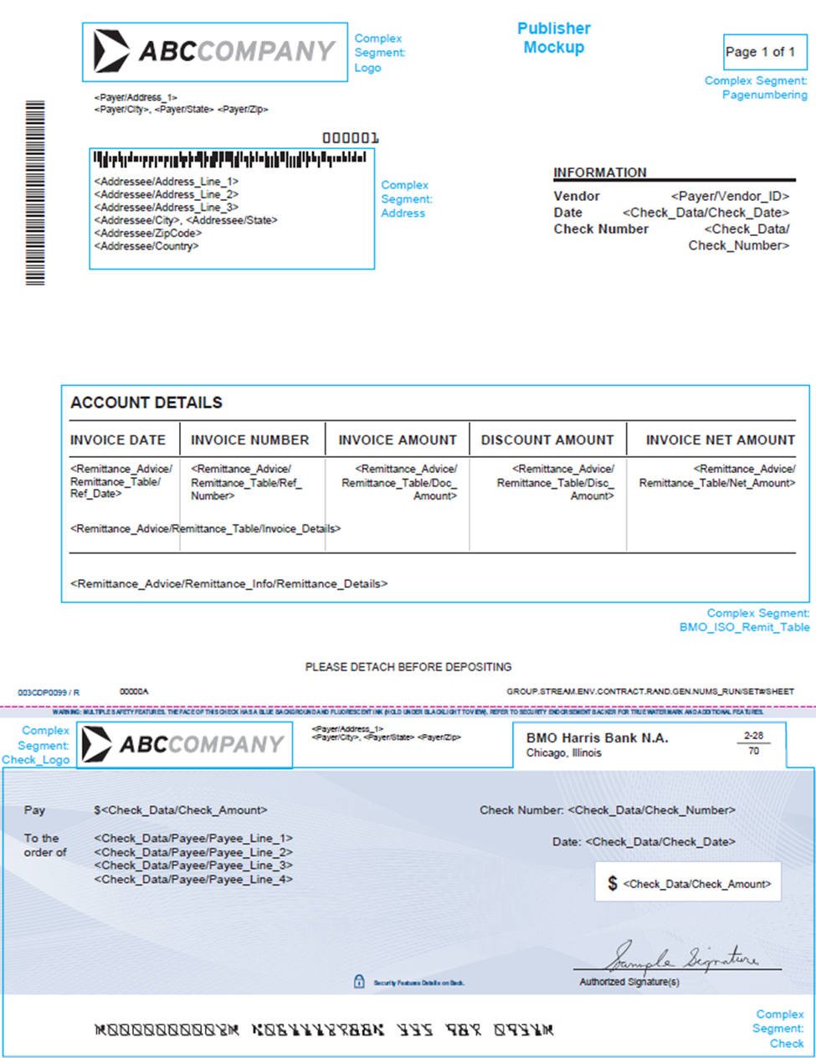 59

Project Overview

Overview
TODO: Ensure the text in angled brackets (e.g. <TBA>) is replaced with information specific to the development.
This document outlines some of the key requirements for the BMO-US ISO Check Implementation Project. This Functional Requirement Document should be read by both Business Analyst and Developer to get a better understanding of what needs to be delivered for this project.

This document is intended to provide the requirements needed for implementation of the BMO-US ISO Check project. It is not intended to specify how those requirements should be implemented.

Intended Audience
TODO: Add any additional contacts here.
The intended audience of this document consists of the following groups:
- CCS Project Management
- CCS Solutions
- CCS CTG Development
- CCS QA/QC

Project Overview
This is an initiative to implement the composition, printing, and mailing of Check, along with appropriate reconciliation and reporting for BMO-US on behalf of their clients. The delivery of a successful project would continue to regularly compose, print, and mail of Checks.

Solution Design Considerations
This project will result in composing and implementing Checks for BMO-US on behalf of their clients and the areas that each team will be involved in to ensure the Checks project is handled as expected. As such, the Information provided needs to be written so that it is scalable, maintainable and easy for the AM, PM, CTG and Solution teams to understand.

Assumptions
- Once live in production, Computershare will not need approval from BMO-US before printing and mailing any files.
- In the event that a Check needs to be pulled from the mail and returned to BMO-US or destroyed, BMO-US will submit a request to their designated Computershare Account Manager and the process will be handled manually.
- No changes to BMO’s existing EDI check process will be implemented through this project.

Reference Documents
- Check Complex Segment Specs.docx

Technical Requirements
The functional requirements below will provide an understanding of the processes and files managed in this project. All teams involved with this Checks Project shall reference this section for both general and specific information.

Aardvark Contract

Aardvark Contract Setup
R21110 | Aardvark contract will be setup according to the following values and fields:  Contract Field Value  Client Code 145BM  UAT Contract Code 145BM0100  Prod Contract Code 145BM0100  UAT Job Bag Number 152679  Production Job Bag Number 508581

Aardvark Contract Job Bag
R21210 | Communication piece stock codes will be the following:  003CDP0075 – Letter Size Check  001CD80035 – Letter Size Plain White
R21220 | Envelope stock codes will be the following:  001CD20024 - Number 10  001CD20051 – Number 10  003CD20009 - 6x9  001CD20097 – 6x9  001CD20014 - 9x12

Aardvark Job Bag Stream Setup
R21310 | Ref# Stream Name Description Group Tag Stream Type Plex Type Prodocution Workflow Comms Pieces Outer Archiving  1 145BM0100_DOM_Sm_<RunNumber> Domestic Small BMOCheck Production Simplex Print > Mail by Machine > Lodge Cheque, P2 001CD20024 N/A  2 145BM0100 _DS_Sm_<RunNumber> Domestic Single Sheet Small BMOCheck Production Simplex Print > Mail by Machine > Lodge Cheque 001CD20024 N/A  3 145BM0100 _DOM_Md_<RunNumber> Domestic Medium BMOCheck Production Simplex Print > Mail by Machine > Lodge Cheque, P2 001CD20007  4 145BM0100 _DOM_Lg_<RunNumber> Domestic Large BMOCheck Production Simplex Print > Mail by Machine > Lodge Cheque, P2 001CD20014 N/A  5 145BM0100 _FOR_Sm_<RunNumber> Foreign Small BMOCheck Production Simplex Print > Mail by Machine > Lodge Cheque, P2 001CD20024 N/A  6 145BM0100 _FS_Sm_<RunNumber> Foreign Single Sheet Small BMOCheck Production Simplex Print > Mail by Machine > Lodge Cheque 001CD20024 N/A  7 145BM0100 _FOR_Md_<RunNumber> Foreign Medium BMOCheck Production Simplex Print > Mail by Machine > Lodge Cheque, P2 001CD20007 N/A  8 145BM0100 _FOR_Lg_<RunNumber> Foreign Large BMOCheck Production Simplex Print > Mail by Machine > Lodge Cheque, P2 001CD20014 N/A  9 145BM0100 _UPS_Lg_<RunNumber> UPS Large BMOCheck Production Simplex Print > Dispatch Cheque, P2 003CDE0052 N/A  10 145BM0100 _UPSBulk_Lg_<RunNumber> UPS Bulk Large BMOCheck Production Simplex Print > Dispatch Cheque, P2 003CDE0052 N/A  11 145BM0100 _FEDEX_Lg_<RunNumber> FedEx Large BMOCheck Production Simplex Print > Dispatch Cheque, P2 008FUX0001 N/A  12 145BM0100 _FEDEXBulk_Lg_<RunNumber> FedEx Bulk Large BMOCheck Production Simplex Print > Dispatch Cheque, P2 008FUX0001 N/A

FTP File Transfer
R22010 | Test and Production folders shall be created for CCS to receive files from BMO-US via sFTP.
R22020 | All files between Computershare and BMO-US will be sent via sFTP as per the details outlined in the BRD with the following file transfer details.  Purpose Folder Location  Test File – To CCS UAT FTP: \\csavcdsfpd1\GE\UAT\DataIn\BMO_145BM\145BM0100\In  Live File – To CCS Prod FTP: \\Csacfp6\CCSNAGE\DataIn\BMO_145BM\145BM0100\In  Test File – From CCS UAT FTP: \\csavcdsfpd1\GE\UAT\DataIn\BMO_145BM\145BM0100\Out  Live File – From CCS Prod FTP: \\Csacfp6\CCSNAGE\DataIn\BMO_145BM\145BM0100\Out

enCompass 2
For the onboarding of clients, enCompass 2 will need to be setup to capture the relevant information that will be used in the document composition.

enCompass 2 Requirements
R23110 | Create a new page in enCompass 2 under the Commercial>BMO directory
R23120 | New page should be titled “ISO Check Clients”
R23130 | Account Manager should have ability to add clients under the “ISO Check Clients” directory
R23135 | Client page will be named as per the <Account Number> that is entered for that client
R23140 | Page in enCompass 2 will consist of the following fields:  - Company Name (Required)  - Account Number (Required)  - Special Handling Address (Optional)  - Name  - Character limit: Truncate to the first 35 characters  - Attn:  - Character limit: Truncate to the first 35 characters  - Street Address  - Character limit: Truncate to the first 35 characters  - City  - Character limit: Truncate to the first 30 characters  - State  - Character limit: Truncate to the first 30 characters  - Zip Code  - Character limit: Truncate to the first 10 characters  - Business Rule for 2nd Signature (Required)  - Check amount greater or equal to:  - Drop down list with the following options (only one option can be selected):  - Not Applicable  - $5,000.00  - $10,000.00  - $15,000.00  - $20,000.00  - Courier Information (Optional)  - Courier Option  - Drop down list with the following options (only one option can be selected):  - UPS  - FEDEX  - Account Number (alphanumeric characters acceptable)  - Bill to Name  - Bill to Phone Number  - Bill to Address  - Street Address  - City  - State  - Zip Code  - Company Email Address (Required)  - Email username  - Email domain  - Email domain extension  - Routing Number (Optional)  - Drop down list with the following options (only one option can be selected):  - 071000288  - 071025661  - PDF Images Required  - Check Box  - Customization (Optional)  - Void text  - This will be a free form text box  - For accounts that produce cashier’s checks, the value need to be: CASHIER’S CHECK  - Place the value in the po.xmll xpath: /CCS/Pack[1]/Check_Data/Void_Text  - 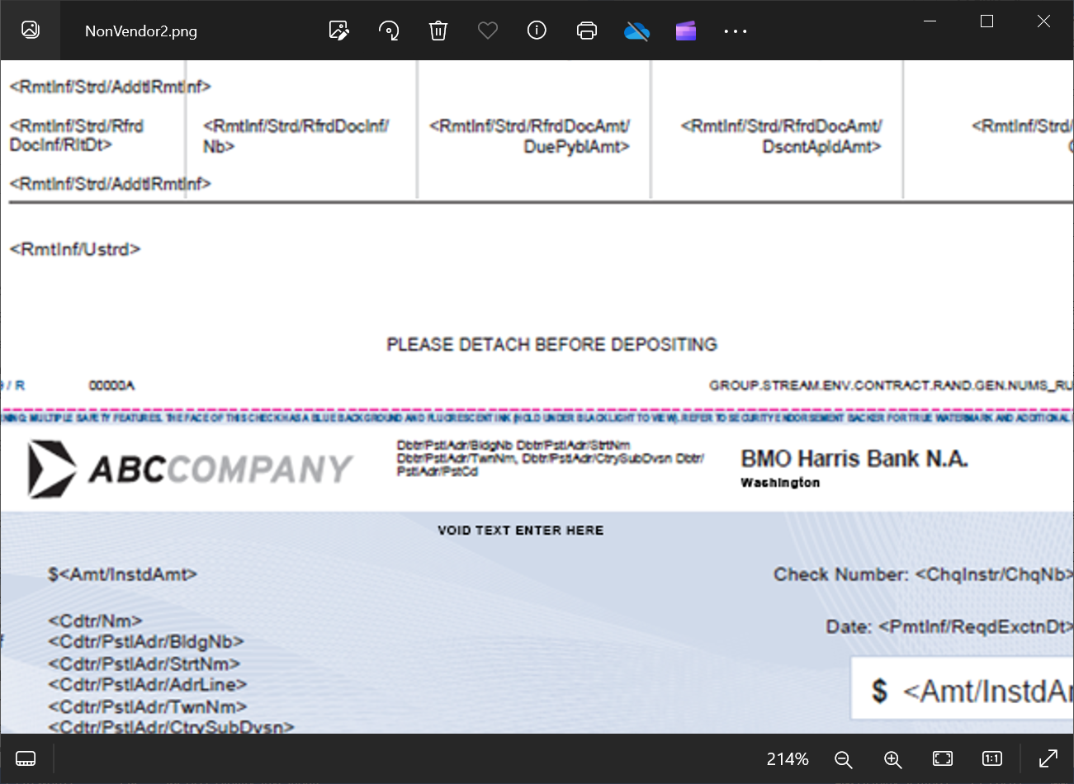  - Bank Address  - Bank Address Line 1 is set in the Aardvark Autoproc Extra Argument  - Bank Address Line 2: [Freeform Text Field]  - Bank Address Line 3: [Freeform Text Field]  - Bank Address Line 4: [Freeform Text Field]  - See example below  -   - Table type (dropdown list)  - Option 1- default (selected by default)  - Option 2-7 column table  - Option 3- Pilgrim table using delimited line  - Zip File Password (Optional)
R23150 | Create an option for a user to run a report that will show the full extract of all customers that are setup
R23152 | The report will be for all clients under Commercial>BMO>ISO Check Clients
R23154 | The report will be an excel (.xlsx) report and will contain the following data:  - Company Name  - Account Number  - Special Handling Name  - Special Handling Attn:  - Special Handling Street Address  - Special Handling City  - Special Handling State  - Special Handling Zip Code  - Business Rule for 2nd Signature  - Courier Option  - Courier Account Number  - Courier Bill to Name  - Courier Bill to Phone Number  - Courier Bill to Street Address  - Courier Bill to City  - Courier Bill to State  - Courier Bill to Zip Code  - Email Address  - Routing Number  - Zip File Password  - Record Last Updated Date (mmddyyyy)
R23156 | Report will be named:  BMO_ISO_Check_Clients_Extract_YYYYMMDDhhmmss.xlsx
R23158 | Report will output to the below directories:  UAT: \\Csafsccsarchive\ccsnage\Archive\BMO_145BM\Encompass_Report\UAT  Prod: \\Csafsccsarchive\ccsnage\Archive\BMO_145BM\Encompass_Report\Prod
R23160 | For all account numbers in Encompass2 that have the “PDF Images Required” box checked off, check images need to be created after Document Composition, with the following naming convention:  PARTY_ID.DEBTOR_ACCT.CHK_NUM.TRAN_ID.pdf  Where the PARTY_ID is extracted from the PO xpath:  CCS/Pack/File_Information/Party_ID  Where the DEBTOR_ACCT is extracted from the PO xpath:  CCS/Pack/Check_Data/Account_Number  And CHK_NUM is the check number is extracted from the PO xpath:  CCS/Pack/Check_Data/Check_Number  And the TRAN_ID is extracted from the PAIN001 file, xml node:  CCS/Pack/File_Information/Tran_ID  Mapping for these PO xpaths can be found in Appendix A
R23165 | The PDF images need to be saved to a zip file with the following naming convention (there may be more than one zip file if there is more than one instance of Customer ID [also described as “PARTY_ID” in R23160] in the PAIN001 files submitted in a given day):  UAT: COMPAYUS.[Customer ID].CHKIMGUST.YYYYMMDD.HHMMSS.PDF.NXXXXXX.zip  Prod: COMPAYUS.[Customer ID].CHKIMGUSP.YYYYMMDD.HHMMSS.PDF.NXXXXXX.zip  Where:  COMPAYUS is hardcoded  And where [Customer ID] is extracted from the PO xpath:  CCS/Pack/File_Information/Party_ID  And where CHKIMGUST [for UAT] or CHKIMGUSP [for Production runs] is hardcoded  And where DATE represents the date the zip file is created, and is formatted: MMDDYYYY  And where TIMESTAMP is formatted: HHMMSS and reflects the time (in EST) the zip file is generated.  And where PDF is hardcoded  And where NXXXXXX = The unique serial number assigned by BMO from the PAIN.001 file
R23170 | Once the zip file(s) is generated, it is to be transmitted via sFTP.

Programming Requirements

Programming Pre-requisites
R24110 | Create a contract shell that allows the ability to sample in Publisher Online for contract code 145BM0100
R24120 | Base complex segments should be available for:  - Logo  - Check_Logo  - Page Numbering  - Mailing Address  - Check

Streaming Logic
R24210 | The streaming logic will be:  Stream Business Rule  145BM0100_DOM_Sm_<RunNumber>.gpd Assign set to stream when: - Xpath: CCS/Pack/Addressee/Country is not present - Sheet Count is 2 to 5 sheets  145BM0100_DS_Sm_<RunNumber>.gpd Assign set to stream when: - Xpath: CCS/Pack/Addressee/Country is not present - Sheet count is 1 sheet  145BM0100_DOM_Md_<RunNumber>.gpd Assign set to stream when: - Xpath: CCS/Pack/Addressee/Country is not present - Sheet count is 6 to 9 sheets  145BM0100_DOM_Lg_<RunNumber>.gpd Assign set to stream when: - Xpath: CCS/Pack/Addressee/Country is not present - Sheet count is 10 sheets or more  145BM0100_FOR_Sm_<RunNumber>.gpd Assign set to stream when: - Xpath: CCS/Pack/Addressee/Country is present - Sheet Count is 2 to 5 sheets  145BM0100_FS_Sm_<RunNumber>.gpd Assign set to stream when: - Xpath: CCS/Pack/Addressee/Country is present - Sheet count is 1 sheet  145BM0100_FOR_Md_<RunNumber>.gpd Assign set to stream when: - Xpath: CCS/Pack/Addressee/Country is present - Sheet count is 6 to 9 sheets  145BM0100_FOR_Lg_>RunNumber>.gpd Assign set to stream when: - Xpath: CCS/Pack/Addressee/Country is present - Sheet count is 10 sheets or more  145BM0100_UPS_Lg_<RunNumber>.gpd Assign set to stream when: - Xpath: CCS/Pack/Payer/Special_Handling is ‘02’ - Xpath: CCS/Pack/File_Information/Courier_Information/Courier_Option is ‘UPS’  145BM0100_UPSBulk_Lg_<RunNumber>.gpd Assign set to stream when: - Xpath: CCS/Pack/Payer/Special_Handling is ’01’ or ‘03’ - Xpath: CCS/Pack/File_Information/Courier_Information/Courier_Option is ‘UPS  145BM0100_FEDEX_Lg_<RunNumber>.gpd Assign set to stream when: - Xpath: CCS/Pack/Payer/Special_Handling is ‘02’ - Xpath: CCS/Pack/File_Information/Courier_Information/Courier_Option is ‘FEDEX’  145BM0100_FEDEXBulk_Lg_<RunNumber>.gpd Assign set to stream when: - Xpath: CCS/Pack/Payer/Special_Handling is ‘01’ or ‘03’ - Xpath: CCS/Pack/File_Information/Courier_Information/Courier_Option is ‘FEDEX’
R24211 | The DOM, DS, FOR, and FS streams should be sorted by weight, with the lowest weight earlier in the stream, with a batch break every 1.0 ounces.
R24212 | Due to the possibility that a set can meet specific criteria for more than one stream, the following priority logic will be used to ensure that there are no stream selection conflicts.  - Xpath: CCS/Pack/Payer/Special_Handling_Code  - All sets with a value of ‘01’ or ‘03’ should be directed to the bulk ship streams (UPSBulk, FEDEXBulk)  - Xpath: CCS/Pack/Payer/Special_Handling_Code  - All sets with a value of ‘02’ should be directed to the courier streams (UPS, FEDEX)  - Xpath: CCS/Pack/Addressee/Country  - All sets with a value that is not ‘US’ should be directed to the foreign streams (FOR_Sm, FS_Sm, FOR, Med, FOR_Lg)  - All remaining sets should be directed to the Domestic streams (DOM_Sm; DS_Sm; DOM_Med, DOM_Lg)
R24220 | For UPS stream, UPS label will be created manually
R24222 | Under the UPS Bulk stream listed below, each set for special handling “01” or “03” having the same batch sort key, shall be grouped together as a batch (batch break), and shall create separate address Header sheets per batch in addition to what is currently in place.  Stream:  145BM0100_UPSBulk_Lg_<RunNumber>.gpd  batch sort key:  Account Number+ Special Handling code (“01 or “03”)+ Payment Information ID  (Batch sort key length for both “01” and “03” shall always be the same)  And as referenced in R24232 & R24236, create an address file and place the file in the same folder with an update to include batch number in the file name (example: 01, 02).  The address excel file will have the following naming convention:  [GPD Name]_<Batch Number>.csv (GPD name must have spaces and underscores removed)  Please note:  For Special handling code “01”, although rare, there could be more than one payment Information ID resulting in more than one address.
R24224 | If xpath: CCS/Pack/Payer/Special_Handling is ‘01’, create an address header sheet that contains the following address information and mappings:  - Text for “X checks in this package.”  - Where “X” is the number of checks in the batch  - Text for “Courier Bill to Account Number:” <CCS/Pack/File_Information/Courier_Information/Account_Number>  - Text for “Courier Bill to Name and Address:”  - <CCS/Pack/File_Information/Courier_Information/Bill_to_Name>  - <CCS/Pack/File_Information/Courier_Information/Bill_to_Address/Street_Address>  - <CCS/Pack/File_Information/Courier_Information/Bill_to_Address/City>, <CCS/Pack/File_Information/Courier_Information/Bill_to_Address/State> <CCS/Pack/File_Information/Courier_Information/Bill_to_Address/Zip_Code>  - Text for “Shipping Address Name and Address:”  - CCS/Pack/Payer/Name  - CCS/Pack/Payer/Address_1  - CCS/Pack/Payer/City, CCS/Pack/Payer/State CCS/Pack/Payer/Zip
R24226 | If xpath: CCS/Pack/Payer/Special_Handling is ‘02’, create an address header sheet that contains the following address information and mappings:  - Text for “X checks in this package.”  - Where “X” is the number of checks in the batch  - Text for “Courier Bill to Account Number:” <CCS/Pack/File_Information/Courier_Information/Account_Number>  - Text for “Courier Bill to Name and Address:”  - <CCS/Pack/File_Information/Courier_Information/Bill_to_Name>  - <CCS/Pack/File_Information/Courier_Information/Bill_to_Address/Street_Address>  - <CCS/Pack/File_Information/Courier_Information/Bill_to_Address/City>, <CCS/Pack/File_Information/Courier_Information/Bill_to_Address/State> <CCS/Pack/File_Information/Courier_Information/Bill_to_Address/Zip_Code>  - Text for “Shipping Address Name and Address is Address on Record.”
R24228 | If xpath: CCS/Pack/Payer/Special_Handling is ‘03’, create an address header sheet that contains the following address information and mappings:  - Text for “X checks in this package.”  - Where “X” is the number of checks in the batch  - Text for “Courier Bill to Account Number:” <CCS/Pack/File_Information/Courier_Information/Account_Number>  - Text for “Courier Bill to Name and Address:”  - <CCS/Pack/File_Information/Courier_Information/Bill_to_Name>  - <CCS/Pack/File_Information/Courier_Information/Bill_to_Address/Street_Address>  - <CCS/Pack/File_Information/Courier_Information/Bill_to_Address/City>, <CCS/Pack/File_Information/Courier_Information/Bill_to_Address/State> <CCS/Pack/File_Information/Courier_Information/Bill_to_Address/Zip_Code>  - Text for “Shipping Address Name and Address:”  - CCS/Pack/Payer/Special_Handling_Address/Name  - CCS/Pack/Payer/Special_Handling_Address/Attention  - CCS/Pack/Payer/Special_Handling_Address/Address  - CCS/Pack/Payer/Special_Handling_Address/City, CCS/Pack/Payer/Special_Handling_Address/State CCS/Pack/Payer/Special_Handling_Address/Zip_Code
R24230 | Create an address file for all UPS batches
R24232 | If xpath: CCS/Pack/Payer/Special_Handling is ‘01’  The address file will have the following headers and data mappings:  - CustomerID  - Leave Blank  - CompanyName  - Map from xpath: CCS/Pack/Payer/Name  - Attention  - Leave Blank  - Address1  - Map from xpath: CCS/Pack/Payer/Address_1  - Address2  - Leave Blank  - Address3  - Leave Blank  - City  - Map from xpath: CCS/Pack/Payer/City  - State  - Map from xpath: CCS/Pack/Payer/State  - Zipcode  - Map from xpath: CCS/Pack/Payer/Zip  - Email  - Leave Blank  - Phone  - Leave Blank  - Reference1  - Map from xpath: CCS/Pack/File_Information/Courier_Information/Bill_to_Name  - Truncate after 35 characters  - Reference2  - Leave blank  - Weight  - Leave blank  - Service  - Populate as “1DA”  - PackageType  - Populate as “EE”  - Truncate after 2 characters  - BillTransportationTo  - Populate as “TP”  - bill_to_name  - Map from xpath: CCS/Pack/File_Information/Courier_Information/Bill_to_Name  - bill_to_address  - Map from xpath: CCS/Pack/File_Information/Courier_Information/Bill_to_Address/Street_Address  - bill_to_country  - Populate as “US”  - bill_to_zip  - Map from xpath: CCS/Pack/File_Information/Courier_Information/Bill_to_Address/Zip_Code  - bill_to_city  - Map from xpath: CCS/Pack/File_Information/Courier_Information/Bill_to_Address/City  - bill_to_state  - Map from xpath: CCS/Pack/File_Information/Courier_Information/Bill_to_Address/State  - bill_to_account  - Map from xpath: CCS/Pack/File_Information/Courier_Information/Account_Number  The comma-separated values (.csv) file will have the above data elements mapped for all files and will have the first record in the file as the header row. If the corresponding field is blank, then the file will be blank for that field.  The comma-separated values (.csv) file will have the following naming convention:  [GPD Name].csv (GPD name must have spaces and underscores removed)  The comma-separated values (.csv) will be placed in the following location:  UAT: \\chibfs1\chidata2\Production\Fulfillment-Warehouse\BMO_Checks\UPS\UAT  Prod: \\chibfs1\chidata2\Production\Fulfillment-Warehouse\BMO_Checks\UPS
R24234 | If xpath: CCS/Pack/Payer/Special_Handling is ‘02’  The address file will have the following headers and data mappings:  - CustomerID  - Leave Blank  - CompanyName  - Map from xpath: CCS/Pack/Addressee/Address_Line_1  - Attention  - Leave Blank  - Address1  - Map from xpath: CCS/Pack/Addressee/Address_Line_2  - Address2  - Map from xpath: CCS/Pack/Addressee/Address_Line_3  - Address3  - Leave Blank  - City  - Map from xpath: CCS/Pack/Addressee/City  - State  - Map from xpath: CCS/Pack/Addressee/State  - Zipcode  - Map from xpath: CCS/Pack/Addressee/ZipCode  - Email  - Leave Blank  - Phone  - Leave Blank  - Reference1  - Map from xpath: CCS/Pack/File_Information/Courier_Information/Bill_to_Name  - Truncate after 35 characters  - Reference2  - Leave blank  - Weight  - Leave blank  - Service  - Populate as “1DA”  - PackageType  - Populate as “EE”  - Truncate after 2 characters  - BillTransportationTo  - Populate as “TP”  - bill_to_name  - Map from xpath: CCS/Pack/File_Information/Courier_Information/Bill_to_Name  - bill_to_address  - Map from xpath: CCS/Pack/File_Information/Courier_Information/Bill_to_Address/Street_Address  - bill_to_country  - Populate as “US”  - bill_to_zip  - Map from xpath: CCS/Pack/File_Information/Courier_Information/Bill_to_Address/Zip_Code  - bill_to_city  - Map from xpath: CCS/Pack/File_Information/Courier_Information/Bill_to_Address/City  - bill_to_state  - Map from xpath: CCS/Pack/File_Information/Courier_Information/Bill_to_Address/State  - bill_to_account  - Map from xpath: CCS/Pack/File_Information/Courier_Information/Account_Number  The comma-separated values (.csv) file will have the above data elements mapped for all files and will have the first record in the file as the header row. If the corresponding field is blank, then the file will be blank for that field.  The comma-separated values (.csv) file will have the following naming convention:  [GPD Name].csv (GPD name must have spaces and underscores removed)  The comma-separated values (.csv) will be placed in the following location:  UAT: \\chibfs1\chidata2\Production\Fulfillment-Warehouse\BMO_Checks\UPS\UAT  Prod: \\chibfs1\chidata2\Production\Fulfillment-Warehouse\BMO_Checks\UPS
R24236 | If xpath: CCS/Pack/Payer/Special_Handling is ‘03’  The address file will have the following headers and data mappings:  - CustomerID  - Leave Blank  - CompanyName  - Map from xpath: CCS/Pack/Payer/Special_Handling_Address/Name  - Attention  - Map from xpath: CCS/Pack/Payer/Special_Handling_Address/Attention  - Address1  - Map from xpath: CCS/Pack/Payer/Special_Handling_Address/Address  - Address2  - Leave Blank  - Address3  - Leave Blank  - City  - Map from xpath: CCS/Pack/Payer/Special_Handling_Address/City  - State  - Map from xpath: CCS/Pack/Payer/Special_Handling_Address/State  - Zipcode  - Map from xpath: CCS/Pack/Payer/Special_Handling_Address/Zip_Code  - Email  - Leave Blank  - Phone  - Leave Blank  - Reference1  - Map from xpath: CCS/Pack/File_Information/Courier_Information/Bill_to_Name  - Truncate after 35 characters  - Reference2  - Leave blank  - Weight  - Leave blank  - Service  - Populate as “1DA”  - PackageType  - Populate as “EE”  - Truncate after 2 characters  - BillTransportationTo  - Populate as “TP”  - bill_to_name  - Map from xpath: CCS/Pack/File_Information/Courier_Information/Bill_to_Name  - bill_to_address  - Map from xpath: CCS/Pack/File_Information/Courier_Information/Bill_to_Address/Street_Address  - bill_to_country  - Populate as “US”  - bill_to_zip  - Map from xpath: CCS/Pack/File_Information/Courier_Information/Bill_to_Address/Zip_Code  - bill_to_city  - Map from xpath: CCS/Pack/File_Information/Courier_Information/Bill_to_Address/City  - bill_to_state  - Map from xpath: CCS/Pack/File_Information/Courier_Information/Bill_to_Address/State  - bill_to_account  - Map from xpath: CCS/Pack/File_Information/Courier_Information/Account_Number  The comma-separated values (.csv) file will have the above data elements mapped for all files and will have the first record in the file as the header row. If the corresponding field is blank, then the file will be blank for that field.  The comma-separated values (.csv) file will have the following naming convention:  [GPD Name].csv (GPD name must have spaces and underscores removed)  The comma-separated values (.csv) will be placed in the following location:  UAT: \\chibfs1\chidata2\Production\Fulfillment-Warehouse\BMO_Checks\UPS\UAT  Prod: \\chibfs1\chidata2\Production\Fulfillment-Warehouse\BMO_Checks\UPS
R24240 | For the FEDEX stream, labels will need to be created manually
R24242 | Under the FEDEX Bulk stream listed below, each set for special handling “01” or “03” having the same batch sort key, shall be grouped together as a batch (batch break), and shall create separate address Header sheets per batch in addition to what is currently in place.  Stream:  145BM0100_FEDEXBulk_Lg_<RunNumber>.gpd  batch sort key:  Account Number+ Special Handling code (“01 or “03”) + Payment Information ID  (Batch sort key length for both “01” and “03” shall always be the same)  And as referenced in R24252 & R25456, create an address file and place the file in the same folder with an update to include batch number in the file name (example: 01, 02).  The address excel file will have the following naming convention:  [GPD Name]_<Batch Number>.csv (GPD name must have spaces and underscores removed)  Please note:  For Special handling code “01”, although rare, there could be more than one payment Information ID resulting in more than one address.
R24244 | If xpath: CCS/Pack/Payer/Special_Handling is ‘01’, create an address header sheet that contains the following address information and mappings:  - Text for “X checks in this package.”  - Where “X” is the number of checks in the batch  - Text for “Courier Bill to Account Number:” <CCS/Pack/File_Information/Courier_Information/Account_Number>  - Text for “Courier Bill to Name and Address:”  - <CCS/Pack/File_Information/Courier_Information/Bill_to_Name>  - <CCS/Pack/File_Information/Courier_Information/Bill_to_Address/Street_Address>  - <CCS/Pack/File_Information/Courier_Information/Bill_to_Address/City>, <CCS/Pack/File_Information/Courier_Information/Bill_to_Address/State> <CCS/Pack/File_Information/Courier_Information/Bill_to_Address/Zip_Code>  - Text for “Shipping Address Name and Address:”  - CCS/Pack/Payer/Name  - CCS/Pack/Payer/Address_1  - CCS/Pack/Payer/City, CCS/Pack/Payer/State CCS/Pack/Payer/Zip
R24246 | If xpath: CCS/Pack/Payer/Special_Handling is ‘02’, create an address header sheet that contains the following address information and mappings:  - Text for “X checks in this package.”  - Where “X” is the number of checks in the batch  - Text for “Courier Bill to Account Number:” <CCS/Pack/File_Information/Courier_Information/Account_Number>  - Text for “Courier Bill to Name and Address:”  - <CCS/Pack/File_Information/Courier_Information/Bill_to_Name>  - <CCS/Pack/File_Information/Courier_Information/Bill_to_Address/Street_Address>  - <CCS/Pack/File_Information/Courier_Information/Bill_to_Address/City>, <CCS/Pack/File_Information/Courier_Information/Bill_to_Address/State> <CCS/Pack/File_Information/Courier_Information/Bill_to_Address/Zip_Code>  - Text for “Shipping Address Name and Address is Address on Record.”
R24248 | If xpath: CCS/Pack/Payer/Special_Handling is ‘03’, create an address header sheet that contains the following address information and mappings:  - Text for “X checks in this package.”  - Where “X” is the number of checks in the batch  - Text for “Courier Bill to Account Number:” <CCS/Pack/File_Information/Courier_Information/Account_Number>  - Text for “Courier Bill to Name and Address:”  - <CCS/Pack/File_Information/Courier_Information/Bill_to_Name>  - <CCS/Pack/File_Information/Courier_Information/Bill_to_Address/Street_Address>  - <CCS/Pack/File_Information/Courier_Information/Bill_to_Address/City>, <CCS/Pack/File_Information/Courier_Information/Bill_to_Address/State> <CCS/Pack/File_Information/Courier_Information/Bill_to_Address/Zip_Code>  - Text for “Shipping Address Name and Address:”  - CCS/Pack/Payer/Special_Handling_Address/Name  - CCS/Pack/Payer/Special_Handling_Address/Attention  - CCS/Pack/Payer/Special_Handling_Address/Address  - CCS/Pack/Payer/Special_Handling_Address/City, CCS/Pack/Payer/Special_Handling_Address/State CCS/Pack/Payer/Special_Handling_Address/Zip_Code
R24250 | Create an address file for all FedEx batches
R24252 | If xpath: CCS/Pack/Payer/Special_Handling is ‘01’ the address file will have the following data mappings (no field headers):  - COMPANY  - Map from xpath: CCS/Pack/File_Information/Company_Name  - CLIENT  - Hardcode as “BMO-US”  - BILL TO ACCOUNT NUMBER  - Map from xpath: CCS/Pack/File_Information/Courier_Information/Account_Number  - NAME  - Map from xpath: CCS/Pack/Payer/Name  - EMPTY CELL  - ADDRESS 1  - Map from xparth: CCS/Pack/Payer/Address_1  - EMPTY CELL  - CITY  - Map from xpath: CCS/Pack/Payer/City  - STATE  - Map from xpath: CCS/Pack/Payer/State  - ZIP  - Map from xpath: CCS/Pack/Payer/Zip  - BILL TO NAME  - Map from xpath: CCS/Pack/File_Information/Courier_Information/Bill_to_Name  - BILL TO ADDRESS  - Map from xpath: CCS/Pack/File_Information/Courier_Information/Bill_to_Address/Street_Address  - EMPTY CELL  - BILL TO CITY  - Map from xpath: CCS/Pack/File_Information/Courier_Information/Bill_to_Address/City  - BILL TO STATE  - Map from xpath: CCS/Pack/File_Information/Courier_Information/Bill_to_Address/State  - BILL TO ZIP CODE  - Map from xpath: CCS/Pack/File_Information/Courier_Information/Bill_to_Address/Zip_Code  The tab-delimited file will have the above data elements mapped for all files. If the corresponding field is blank, then the file will be blank for that field.  The excel file will have the following naming convention:  [GPD Name].xls (GPD name must have spaces and underscores removed)  The excel will be placed in the following location:  UAT: \\chibfs1\chidata2\Production\Fulfillment-Warehouse\BMO_Checks\FedEx\UAT  Prod: \\chibfs1\chidata2\Production\Fulfillment-Warehouse\BMO_Checks\FedEx
R24254 | If xpath: CCS/Pack/Payer/Special_Handling is ‘02’ the address file will have the following data mappings (no field headers):  - COMPANY  - Map from xpath: CCS/Pack/File_Information/Company_Name  - CLIENT  - Hardcode as “BMO-US”  - BILL TO ACCOUNT NUMBER  - Map from xpath: CCS/Pack/File_Information/Courier_Information/Account_Number  - NAME  - Map from xpath: CCS/Pack/Addressee/Address_Line_1  - EMPTY CELL  - ADDRESS 1  - Map from xpath: CCS/Pack/Addressee/Address_Line_2  - ADDRESS 2  - Map from xpath: CCS/Pack/Addressee/Address_Line_3  - CITY  - Map from xpath: CCS/Pack/Addressee/City  - STATE  - Map from xpath: CCS/Pack/Addressee/State  - ZIP  - Map from xpath: CCS/Pack/Addressee/ZipCode  - BILL TO NAME  - Map from xpath: CCS/Pack/File_Information/Courier_Information/Bill_to_Name  - BILL TO ADDRESS  - Map from xpath: CCS/Pack/File_Information/Courier_Information/Bill_to_Address/Street_Address  - EMPTY CELL  - BILL TO CITY  - Map from xpath: CCS/Pack/File_Information/Courier_Information/Bill_to_Address/City  - BILL TO STATE  - Map from xpath: CCS/Pack/File_Information/Courier_Information/Bill_to_Address/State  - BILL TO ZIP CODE  - Map from xpath: CCS/Pack/File_Information/Courier_Information/Bill_to_Address/Zip_Code  The tab-delimited file will have the above data elements mapped for all files. If the corresponding field is blank, then the file will be blank for that field.  The excel file will have the following naming convention:  [GPD Name].xls (GPD name must have spaces and underscores removed)  The excel will be placed in the following location:  UAT: \\chibfs1\chidata2\Production\Fulfillment-Warehouse\BMO_Checks\FedEx\UAT  Prod: \\chibfs1\chidata2\Production\Fulfillment-Warehouse\BMO_Checks\FedEx
R25456 | If xpath: CCS/Pack/Payer/Special_Handling is ‘03’ the address file will have the following data mappings (no field headers):  - COMPANY  - Map from xpath: CCS/Pack/File_Information/Company_Name  - CLIENT  - Hardcode as “BMO-US”  - BILL TO ACCOUNT NUMBER  - Map from xpath: CCS/Pack/File_Information/Courier_Information/Account_Number  - NAME  - Map from xpath: CCS/Pack/Payer/Special_Handling_Address/Name  - EMPTY CELL  - ADDRESS 1  - Map from xparth: CCS/Pack/Payer/Special_Handling_Address/Address  - EMPTY CELL  - CITY  - Map from xpath: CCS/Pack/Payer/Special_Handling_Address/City  - STATE  - Map from xpath: CCS/Pack/Payer/Special_Handling_Address/State  - ZIP  - Map from xpath: CCS/Pack/Payer/Special_Handling_Address/Zip_Code  - BILL TO NAME  - Map from xpath: CCS/Pack/File_Information/Courier_Information/Bill_to_Name  - BILL TO ADDRESS  - Map from xpath: CCS/Pack/File_Information/Courier_Information/Bill_to_Address/Street_Address  - EMPTY CELL  - BILL TO CITY  - Map from xpath: CCS/Pack/File_Information/Courier_Information/Bill_to_Address/City  - BILL TO STATE  - Map from xpath: CCS/Pack/File_Information/Courier_Information/Bill_to_Address/State  - BILL TO ZIP CODE  - Map from xpath: CCS/Pack/File_Information/Courier_Information/Bill_to_Address/Zip_Code  The tab-delimited file will have the above data elements mapped for all files. If the corresponding field is blank, then the file will be blank for that field.  The excel file will have the following naming convention:  [GPD Name].xls (GPD name must have spaces and underscores removed)  The excel will be placed in the following location:  UAT: \\chibfs1\chidata2\Production\Fulfillment-Warehouse\BMO_Checks\FedEx\UAT  Prod: \\chibfs1\chidata2\Production\Fulfillment-Warehouse\BMO_Checks\FedEx

File Specifications
R24310 | Files will be received every day, at multiple times during the day
R24312 | File pulling interval shall occur every 1 minute from the 00:01 until 00:00 to ensure that all files have been retrieved from the FTP location.
R24320 | XML file will be sent to CCS by BMO and will be formatted as per the ISO20022 PAIN.001.001.03 format.
R24321 | See Appendix D for File Level Validations
R24340 | XML file will be named:  UAT: T.COMSHARUS.[Customer ID].PAIN001.YYYYMMDD.HHMMSS.NXXXXXX.xml  UAT: T.COMSHARUS.[Customer ID].PAIN001.NONVEND.YYYYMMDD.HHMMSS.NXXXXXX.xml  UAT: T.COMSHARUS.[Customer ID].PAIN001.VEND.YYYYMMDD.HHMMSS.NXXXXXX.xml  UAT: T.COMSHARUS.[Customer ID].PAIN001.CUSTTABLE.YYYYMMDD.HHMMSS.NXXXXXX.xml  Prod: P.COMSHARUS.[Customer ID].PAIN001.YYYYMMDD.HHMMSS.NXXXXXX.xml  Prod: P.COMSHARUS.[Customer ID].PAIN001.NONVEND.YYYYMMDD.HHMMSS.NXXXXXX.xml  Prod: P.COMSHARUS.[Customer ID].PAIN001.VEND.YYYYMMDD.HHMMSS.NXXXXXX.xml  Prod: P.COMSHARUS.[Customer ID].PAIN001.CUSTTABLE.YYYYMMDD.HHMMSS.NXXXXXX.xml  Where:  [Customer ID] = A unique value for that customer within BMO  NXXXXXX = A unique serial number assigned by BMO

Client File to PO File mapping
R24410 | See Appendix A for BMO to PO data field xpath mapping table.
R24412 | If the input file contains extra fields that are not listed in Appendix A, file processing should ignore those fields unless they alter the hierarchy of the expected XML
R24420 | For the Addressee Address Lines, as mapped in Appendix A:  This is to be taken into account per Payment Info Group (/Document/CstmrCdtTrfInitn/PmtInf)  If either just the Payee Street Name data field: Document/CstmrCdtTrfInitn/PmtInf/CdtTrfTxInf/Cdtr/PstlAdr/ StrtNm  or both the [optional] Payee Building Number /Document/CstmrCdtTrfInitn/PmtInf/CdtTrfTxInf/Cdtr/PstlAdr/ BldgNb  and Payee Street Name: Document/CstmrCdtTrfInitn/PmtInf/CdtTrfTxInf/Cdtr/PstlAdr/ StrtNm  data fields are not passed in the PAIN001, then 2 instances of the Payee Address Line data field: /Document/CstmrCdtTrfInitn/PmtInf/CdtTrfTxInf/Cdtr/PstlAdr/AdrLine  can be passed in the data file and will be placed on the check as CCS/Pack/Addressee/Address_Line_2 and CCS/Pack/Addressee/Address_Line_3 in the order they are received in the data file. Any additional instances of the Payee Address Line data fields: /Document/CstmrCdtTrfInitn/PmtInf/CdtTrfTxInf/Cdtr/PstlAdr/AdrLine  found in the PAIN001 can be ignored, and the file should continue processing.  If either just the Payee Street Name data field:  Document/CstmrCdtTrfInitn/PmtInf/CdtTrfTxInf/Cdtr/PstlAdr/ StrtNm  or both the Payee Building Number /Document/CstmrCdtTrfInitn/PmtInf/CdtTrfTxInf/Cdtr/PstlAdr/ BldgNb  and Payee Street Name Document/CstmrCdtTrfInitn/PmtInf/CdtTrfTxInf/Cdtr/PstlAdr/ StrtNm  data fields are passed in the PAIN001, then only one instance of the Payee Address Line data field: /Document/CstmrCdtTrfInitn/PmtInf/CdtTrfTxInf/Cdtr/PstlAdr/AdrLine  can be accepted and printed on the check.  The Payee Street Name Document/CstmrCdtTrfInitn/PmtInf/CdtTrfTxInf/Cdtr/PstlAdr/ StrtNm and Payee Building Number /Document/CstmrCdtTrfInitn/PmtInf/CdtTrfTxInf/Cdtr/PstlAdr/ BldgNb would be mapped to  CCS/Pack/Addressee/Address_Line_2  And the additional one instance of the Payee Address Line data field  /Document/CstmrCdtTrfInitn/PmtInf/CdtTrfTxInf/Cdtr/PstlAdr/AdrLine  Would be mapped to CCS/Pack/Addressee/Address_Line_3.  Any additional instances of the Payee Address Line data field /Document/CstmrCdtTrfInitn/PmtInf/CdtTrfTxInf/Cdtr/PstlAdr/AdrLine  found in the PAIN001 can be ignored, and the file should continue processing.
R24430 | For the Check Details Address Lines, as mapped in Appendix A:  This is to be taken into account per Transaction Level Group (/Document/CstmrCdtTrfInitn/PmtInf/TxInf)  If either just the Payee Street Name data field: Document/CstmrCdtTrfInitn/PmtInf/CdtTrfTxInf/Cdtr/PstlAdr/ StrtNm  or both the [optional] Payee Building Number /Document/CstmrCdtTrfInitn/PmtInf/CdtTrfTxInf/Cdtr/PstlAdr/ BldgNb  and Payee Street Name: Document/CstmrCdtTrfInitn/PmtInf/CdtTrfTxInf/Cdtr/PstlAdr/ StrtNm  data fields are not passed in the PAIN001, then 2 instances of the Payee Address Line data field: /Document/CstmrCdtTrfInitn/PmtInf/CdtTrfTxInf/Cdtr/PstlAdr/AdrLine  can be sent and will be placed on the check as CCS/Pack/Check_Data/Payee/Payee_Line_2 and CCS/Pack/Check_Data/Payee/Payee_Line_3, in the order they are received in the data file. Any additional instances of the Payee Address Line data fields: /Document/CstmrCdtTrfInitn/PmtInf/CdtTrfTxInf/Cdtr/PstlAdr/AdrLine  found in the PAIN001 can be ignored, and the file should continue processing.  If either just the Payee Street Name data field:  Document/CstmrCdtTrfInitn/PmtInf/CdtTrfTxInf/Cdtr/PstlAdr/ StrtNm  or both the Payee Building Number /Document/CstmrCdtTrfInitn/PmtInf/CdtTrfTxInf/Cdtr/PstlAdr/ BldgNb  and Payee Street Name Document/CstmrCdtTrfInitn/PmtInf/CdtTrfTxInf/Cdtr/PstlAdr/ StrtNm  data fields are passed in the PAIN001, then only one instance of the Payee Address Line data field: /Document/CstmrCdtTrfInitn/PmtInf/CdtTrfTxInf/Cdtr/PstlAdr/AdrLine  can be accepted and printed on the check.  The Payee Street Name Document/CstmrCdtTrfInitn/PmtInf/CdtTrfTxInf/Cdtr/PstlAdr/ StrtNm and Payee Building Number /Document/CstmrCdtTrfInitn/PmtInf/CdtTrfTxInf/Cdtr/PstlAdr/ BldgNb would be mapped to  CCS/Pack/Check_Data/Payee/Payee_Line_2  And the additional one instance of the Payee Address Line data field  /Document/CstmrCdtTrfInitn/PmtInf/CdtTrfTxInf/Cdtr/PstlAdr/AdrLine  Would be mapped to CCS/Pack/Check_Data/Payee/Payee_Line_3  Any additional instances of the Payee Address Line data field /Document/CstmrCdtTrfInitn/PmtInf/CdtTrfTxInf/Cdtr/PstlAdr/AdrLine  found in the PAIN001 can be ignored, and the file should continue processing.

Complex Segments
R24510 | The following Complex Segments need to be assigned to the 145BM context to all Groups (named accordingly):  - Logo  - Check_Logo  - Page Numbering  - Mailing Address  - Check
R24511 | The Logo complex segment will look for a Dynamic Signature logo graphic in PO that matches the naming: pattern:  Logo_[Account].pdf  Where [Account] = the value of the following xpaths for Account Number  Document/CstmrCdtTrfInitn/PmtInf/DbtrAcct/Id/Othr/Id CCS/Pack/Check_Data/Account_Number xs:integer
R24520 | Mailing Address Complex Segment will use the standard Mailing Address Complex segment. Refer to the data mappings for the Addressee fields.
R24530 | The Check Complex Segment will use the standard Check Complex segment. Refer to the data mappings for the Check_Data fields.
R24531 | For MICR and Check Composition details refer to “Check Complex Segment specs.docx”.
R24531.1 | If the routing number ‘071915580’ is found in the bankdetails.ini file, then the number “04” should be used to prepend the account number in MICR line.
R24531.2 | If the routing number from the Pain001 file is not found in the bankdetails.ini file, then the account number in the Pain001 file should be used to derive the routing number from Encompass2.
R24531.4 | If the Routing# passed in the Pain001 file is 121100782, the MICR details for that routing number in bankdetails.ini need to be ignored, and the account number in the Pain001 should be used to lookup the routing # in Encompass2 to be printed on the check.
R24532 | The Check Complex segment will look for a signature graphic that matches the naming pattern:  Signature_[Account].pdf  Where:  [Account] = the value of the following xpaths for Account Number  Document/CstmrCdtTrfInitn/PmtInf/DbtrAcct/Id/Othr/Id CCS/Pack/Check_Data/Account_Number xs:integer
R24534 | If the check amount is greater or equal to the threshold for the business rule to apply a second signature for the client, then the signature graphic that is used would be:  Signature_[Account]_2.pdf
R24535 | The signature graphic will be located in the following directory:  Prod: \\csavcdsfp1\resource\Graphics\PublisherGraphics\BMO  UAT: \\csavcdsfpu1\Resource\Graphics\PublisherGraphics\BMO
R24540 | A new complex segment will need to be created for the remittance table
R24550 | New complex segment will be named: BMO_ISO_Remit_Table
R24560 | Complex segment will create a custom five-column remittance table
R24570 | The first line of the complex segment will be the table title and will have the following specifications:  - Text: ACCOUNT DETAILS  - Font: AriaBoldlMT  - Point size: 12  Text will be placed left justified with a left margin of 1.905 cm
R24580 | Remittance table will be added based on client’s data file and will have the following column width and column headers for P.COMSHARUS.[Customer ID].PAIN001.YYYYMMDD.HHMMSS.NXXXXXX.xml  Column Width Column Header Text  Left Margin 1.905 cm  1st Column 2.8448 cm INVOICE DATE  2nd Column 3.81 cm INVOICE NUMBER  3rd Column 3.81 cm INVOICE AMOUNT  4th Column 4.0894 cm DISCOUNT AMOUNT  5th Column 4.3434 cm INVOICE NET AMOUNT  Right Margin 0.635 cm  Text for each column header will be center justified and will be in the following font:  - Font: ArialBoldMT  - Point Size: 10
R24581 | Remittance table will be added based on client’s data file and will have the following column width and column headers for P.COMSHARUS.[Customer ID].PAIN001.NONVEND.YYYYMMDD.HHMMSS.NXXXXXX.xml  Column Width Column Header Text  Left Margin 1.905 cm  1st Column 2.8448 cm DATE OF LOSS  2nd Column 3.81 cm CLAIM NUMBER  3rd Column 3.81 cm PAID AMOUNT  4th Column 4.0894 cm DEDUCTIONS  5th Column 4.3434 cm NET PAID AMOUNT  Right Margin 0.635 cm  Text for each column header will be center justified and will be in the following font:  - Font: ArialBoldMT  - Point Size: 10
R24582 | Remittance table will be added based on client’s data file and will have the following column width and column headers for P.COMSHARUS.[Customer ID].PAIN001.VEND.YYYYMMDD.HHMMSS.NXXXXXX.xml  Column Width Column Header Text  Left Margin 1.905 cm  1st Column 2.8448 cm INVOICE DATE  2nd Column 3.81 cm CLAIM NUMBER/INVOICE NUMBER  3rd Column 3.81 cm INVOICE AMOUNT  4th Column 4.0894 cm DEDUCTIONS  5th Column 4.3434 cm INVOICE NET AMOUNT  Right Margin 0.635 cm  Text for each column header will be center justified and will be in the following font:  - Font: ArialBoldMT  - Point Size: 10
R24583 | Each row of data in the remittance table will have the following mappings for P.COMSHARUS.[Customer ID].PAIN001.YYYYMMDD.HHMMSS.NXXXXXX.xml:  Column Mapping Rules  INVOICE DATE CCS/Pack/Remittance_Advice/Remittance_Table/Remittance_Row/Ref_Date - Left justified - Format as “MM/DD/YYYY”  INVOICE DATE CCS/Pack/Remittance_Advice/Remittance_Table/Remittance_Row/Invoice_Details - Left justified - If data is present, data should extend across all cells of the table - In the event a client populates the literal NOTE// or DESC// in the <AddtlRmtInf> tag, DO NOT print the literal NOTE// or DESC//. Please suppress these and do not print.  INVOICE NUMBER CCS/Pack/Remittance_Advice/Remittance_Table/Remittance_Row/Ref_Number - Left justified  INVOICE AMOUNT CCS/Pack/Remittance_Advice/Remittance_Table/Remittance_Row/Doc_Amount - Right justified - Format as “$N,NNN.nn” - If xpath CCS/Pack/Remittance_Advice/Remittance_Table/Invoice_Type equals ‘CREN’, format value as “$N,NNN.nn-‘  DISCOUNT AMOUNT CCS/Pack/Remittance_Advice/Remittance_Table/Remittance_Row/Disc_Amount - Right justified - Format as “$N,NNN.nn” - If xpath CCS/Pack/Remittance_Advice/Remittance_Table/Invoice_Type equals ‘CINV’, format value as “$N,NNN.nn-‘  INVOICE NET AMOUNT CCS/Pack/Remittance_Advice/Remittance_Table/Remittance_Row/Net_Amount - Right justified - Format as “$N,NNN.nn” - If xpath CCS/Pack/Remittance_Advice/Remittance_Table/Invoice_Type equals ‘CREN’, format value as “$N,NNN.nn-‘  All data in the table should be in the following font:  - Font: ArialMT  - Point: 10 pt  Add text “Additional details on reverse” below the remittance table when table paginates.  Center aligned and ArialBoldMT Size 10
R24584 | Each row of data in the remittance table will have the following mappings for P.COMSHARUS.[Customer ID].PAIN001.NONVEND.YYYYMMDD.HHMMSS.NXXXXXX.xml:  Column Mapping Rules  INVOICE DATE CCS/Pack/Remittance_Advice/Remittance_Table/Remittance_Row/Ref_Date - Left justified - Format as “MM/DD/YYYY”  INVOICE DATE CCS/Pack/Remittance_Advice/Remittance_Table/Remittance_Row/Invoice_Details - Left justified - If data is present, data should extend across all cells of the table In the event a client populates the literal NOTE// or DESC// in the <AddtlRmtInf> tag, DO NOT print the literal NOTE// or DESC//. Please suppress these and do not print.  CLAIM NUMBER / INVOICE NUMBER CCS/Pack/Remittance_Advice/Remittance_Table/Remittance_Row/Ref_Number - Left justified  INVOICE AMOUNT CCS/Pack/Remittance_Advice/Remittance_Table/Remittance_Row/Doc_Amount - Right justified - Format as “$N,NNN.nn” - If xpath CCS/Pack/Remittance_Advice/Remittance_Table/Invoice_Type equals ‘CREN’, format value as “$N,NNN.nn-‘  DEDUCTIONS CCS/Pack/Remittance_Advice/Remittance_Table/Remittance_Row/Disc_Amount - Right justified - Format as “$N,NNN.nn” - If xpath CCS/Pack/Remittance_Advice/Remittance_Table/Invoice_Type equals ‘CINV’, format value as “$N,NNN.nn-‘ - If xpath CCS/Pack/Remittance_Advice/Remittance_Table/Disc_amount is empty, default value to $0.00  NET PAID AMOUNT CCS/Pack/Remittance_Advice/Remittance_Table/Remittance_Row/Net_Amount - Right justified - Format as “$N,NNN.nn” - If xpath CCS/Pack/Remittance_Advice/Remittance_Table/Invoice_Type equals ‘CREN’, format value as “$N,NNN.nn-‘  All data in the table should be in the following font:  - Font: ArialMT  Point: 10 pt  Add text “Additional details on reverse” below the remittance table when table paginates.  Center aligned and ArialBoldMT Size 10
R24585 | Each row of data in the remittance table will have the following mappings for P.COMSHARUS.[Customer ID].PAIN001.VEND.YYYYMMDD.HHMMSS.NXXXXXX.xml:  Column Mapping Rules  DATE OF LOSS CCS/Pack/Remittance_Advice/Remittance_Table/Remittance_Row/Ref_Date - Left justified - Format as “MM/DD/YYYY”  DATE OF LOSS CCS/Pack/Remittance_Advice/Remittance_Table/Remittance_Row/Invoice_Details - Left justified - If data is present, data should extend across all cells of the table In the event a client populates the literal NOTE// or DESC// in the <AddtlRmtInf> tag, DO NOT print the literal NOTE// or DESC//. Please suppress these and do not print.  CLAIM NUMBER/INVOICE NUMBER CCS/Pack/Remittance_Advice/Remittance_Table/Remittance_Row/Ref_Number - Left justified  PAID AMOUNT CCS/Pack/Remittance_Advice/Remittance_Table/Remittance_Row/Doc_Amount - Right justified - Format as “$N,NNN.nn” - If xpath CCS/Pack/Remittance_Advice/Remittance_Table/Invoice_Type equals ‘CREN’, format value as “$N,NNN.nn-‘  DEDUCTIONS CCS/Pack/Remittance_Advice/Remittance_Table/Remittance_Row/Disc_Amount - Right justified - Format as “$N,NNN.nn” - If xpath CCS/Pack/Remittance_Advice/Remittance_Table/Invoice_Type equals ‘CINV’, format value as “$N,NNN.nn-‘ - If xpath CCS/Pack/Remittance_Advice/Remittance_Table/Disc_amount is empty, default value to 0-‘- If xpath CCS/Pack/Remittance_Advice/Remittance_Table/Invoice_Type is empty, default value to $0.00  INVOICE NET AMOUNT CCS/Pack/Remittance_Advice/Remittance_Table/Remittance_Row/Net_Amount - Right justified - Format as “$N,NNN.nn” - If xpath CCS/Pack/Remittance_Advice/Remittance_Table/Invoice_Type equals ‘CREN’, format value as “$N,NNN.nn-‘  All data in the table should be in the following font:  - Font: ArialMT  Point: 10 pt  Add text “Additional details on reverse” below the remittance table when table paginates.  Center aligned and ArialBoldMT Size 10
R24586 | Any Holland accounts or for accounts that require the use of Table type option 2 will have the following Remittance table data mappings  INVOICE NUMBER CCS/Pack/Remittance_Advice/Remittance_Table/Remittance_Row/Ref_Number - Left justified  INVOICE NUMBER CCS/Pack/Remittance_Advice/Remittance_Table/Remittance_Row/Invoice_Details - Left justified In the event a client populates the literal NOTE// or DESC// in the <AddtlRmtInf> tag, DO NOT print the literal NOTE// or DESC//. Please suppress these and do not print.  REFERENCE TYPE CCS/Pack/Remittance_Advice/Remittance_Table/Remittance_Row/Ref_Type -Left Justified  REFERENCE ID CCS/Pack/Remittance_Advice/Remittance_Table/Remittance_Row/Ref_ID - Left justified  EFFECTIVE DATE CCS/Pack/Remittance_Advice/Remittance_Table/Remittance_Row/Ref_Date - Left justified - Format as “MM/DD/YYYY”  TOTAL CURRENT AMOUNT CCS/Pack/Remittance_Advice/Remittance_Table/Remittance_Row/Doc_Amount - Right justified - Format as “$N,NNN.nn” - If xpath CCS/Pack/Remittance_Advice/Remittance_Table/Invoice_Type equals ‘CREN’, format value as “$N,NNN.nn-‘  DISCOUNT AMOUNT CCS/Pack/Remittance_Advice/Remittance_Table/Remittance_Row/Disc_Amount - Right justified - Format as “$N,NNN.nn” - If xpath CCS/Pack/Remittance_Advice/Remittance_Table/Invoice_Type equals ‘CINV’, format value as “$N,NNN.nn-‘ - If xpath CCS/Pack/Remittance_Advice/Remittance_Table/Disc_amount is empty, default value to $0.00-  INVOICE ADJUSTMENT CCS/Pack/Remittance_Advice/Remittance_Table/Remittance_Row/Net_Amount - Right justified - Format as “$N,NNN.nn” - If xpath CCS/Pack/Remittance_Advice/Remittance_Table/Invoice_Type equals ‘CREN’, format value as “$N,NNN.nn-‘  All data in the table should be in the following font:  - Font: ArialMT  Point: 10 pt  Add text “Additional details on reverse” below the remittance table when table paginates.  Center aligned and ArialBoldMT Size 10
R24587 | After the table, place the following xpath (if present):  CCS/Pack/Remittance_Advice/Remittance_Info/Remittance_Details  Text should be in the following font:  - Font: ArialMT  - Point: 10 pt
R24588 | Each occurrence of the field described in R24587 is to appear in a new line below the previous line.
R24590 | The rendered complex segment should look like:  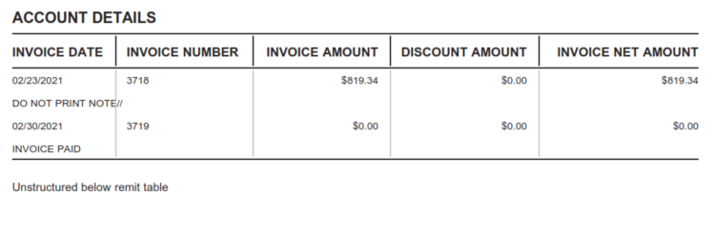  Additional details on reverse
R24591 | Pilgrims Pride Corp will use Table option 3 and come in as:  P.COMSHARUS.[Customer ID].PAIN001.CUSTTABLE.YYYYMMDD.HHMMSS.NXXXXXX.xml:  For accounts using Table Option 3 there is a set of tags  <Ustrd> tags will be processed in pairs. The first is an 13 position semi colon delimited data line  /CstmrCdtTrfInitn/PmtInf/CdtTrfTxInf/RmtInf/Ustrd  Position 1 Position 2 Position 3 Position 4 Position 5 Position 6 Position 7  PO Ticket Number Contract Price Quantity Bushels Gross Amount Moisture value Test Weight  Character count 10 16 7 9 10 8 8  Data type Numeric Numeric Text Text Text Text Text  Example 1234567890 1234567890123450 99.9999 9,999.999 99,999.99- 9,999.99 9,999.99  Position 8 Position 9 Position 10 Position 11 Position 12 Position 13  Damage number Foreign Material number Discount Total Deferred Pricing Check Off Net Amount  Character count 8 8 8 6 6 10  Data type Text Text Text Text Text Text  Example 9,999.99 9,999.99 9,999.99 999.99 999.99 99,999.99-  Second line is a 6 position semi colon delimited data line.  Position 1 Position 2 Position 3 Position 4 Position 5 Position 6  PO Ticket Date Moisture percent Test Weight percent Damage percent Foreign Material percent  Character count 10 10 5 5 5 5  Data type Numeric Text Text Text Text Text  Example 999 12/12/9999 99.9% 99.9% 99.9% 99.9%  The second line positions should be placed below the first lines columns as follows  Column 1 Column 2 Column 6 Column 7 Column 8 Column 9  Position 1 Position 2 Position 3 Position 4 Position 5 Position 6  There is also a single set of values for the Totals bar at the bottom of the table  <AddtlRmtInf> tag contains a semi colon delimited line  /CstmrCdtTrfInitn/PmtInf/CdtTrfTxInf/RmtInf/Strd/AddtlRmtInf  The line has the following values  [Vendor Name];[Material];[Payment Document]  <Nb> tag will store a single instance of the Quantity Bushels Total  /CstmrCdtTrfInitn/PmtInf/CdtTrfTxInf/RmtInf/Strd/RfrdDocInf/Nb  <DuePyblAmt> tag will store a single instance of the Gross Amount Total  /CstmrCdtTrfInitn/PmtInf/CdtTrfTxInf/RmtInf/Strd/RfrdDocInf/DuePyblAmt  <DscntApldAmt> tag will store a single instance of the Discount Total  /CstmrCdtTrfInitn/PmtInf/CdtTrfTxInf/RmtInf/Strd/RfrdDocInf/DscntApldAmt  <CdtNoteAmt> tag will store a single instance of the Net Total  /CstmrCdtTrfInitn/PmtInf/CdtTrfTxInf/RmtInf/Strd/RfrdDocInf/CdtNoteAmt
R24592 | The Table Option 3 complex segment should look like the following  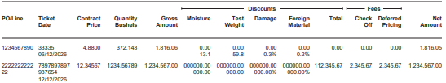  With a totals bar following the table  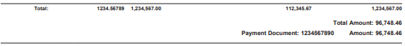

Set Tags
R24610 | The following Monthly Billing Set Tags are to be added in the GPD.  Set Tag Description  202SLD_AccountNumber <Account_Number> [CCS/Pack/Check_Data/Account_Number]  202SLD_FileName CCS/Pack/File_Information/File_Name  202SLD_FileDate To be pulled from highlighted portion of the input file’s name: P.COMSHARUS.[Customer ID].PAIN001.YYYYMMDD.HHMMSS.NXXXXXX.xml Format as: YYYY-MM-DD  202SLD_FollowerImages Per set, the number of images minus the first page
R24620 | Any set tag that does not have a specific value, shall have a value of 0.

Duplicate Check Database
R24710 | During file processing, the following xpaths will be written to the CCS duplicate check database:  CCS/Pack/Check_Data/Routing_Number  CCS/Pack/Check_Data/Account_Number  CCS/Pack/Check_Data/Check_Number
R24720 | If there is a duplicate check number in the database for the same account number and routing number, from a prior file or within the same file, then CCS shall isolate the duplicates found and continue processing the file.  If there is a duplicate check found within the same file, CCS shall process the first check in the file, and isolate the subsequent duplicates found and continue processing the rest of the file.
R24721 | If routing number 121100782 is passed in the Pain001 file and it is bypassed, as described in R24531.4, requirements R24710 and R24720 need to use the routing number obtained from Encompass2 in their logic to process that particular check.
R24730 | If a duplicate check number is identified, create a file that contains the information for the failed record.
R24740 | The file should be a comma-separated values (csv) file that contains the following headers and data mapping:  Header Data Mapping  Check Number CCS/Pack/Check_Data/Check_Number  Check Amount CCS/Pack/Check_Data/Check_Amount  Payee CCS/Pack/Addressee/Address_Line_1  Input File CCS/Pack/File_Information/File_Name  File will be named:  145BM0100_Duplicate_Check_[Run Number].csv
R24745 | The file will be attached to an email that is sent to the CCS AM Team
R24750 | If a duplicate check number is identified, then an email will be sent to the following address:  !USCSBRCreditUnionsOpsCon@computershare.com
R24760 | The email will have a subject line of:  145BM0100 Duplicate Check in [Run Number]  The body of the email will read:  A duplicate check was identified in the below input file(s). Attached is a file that contains the details of the record that failed. Please contact client to let them know that this check was quarantined and did not print,  and the rest of the file continued processing, and printing.  Note: File attachment requirements can be found in R24740

File Consolidation
R24810 | Files will be consolidated for Operational purposes after the initial file conversion is complete to create the po.xml file for the run
R24820 | Po.xml files will be held in a staging directory and will be consolidated based on the below schedule:  - 9:00am ET  - 1:00pm ET  - 1:00am ET  Job automation should be setup to allow for updates to the above schedule as Operational needs warrant
R24830 | The UPSBulk and FEDEXBulk streams will be consolidated based on the following:  - Sets will be sorted into batches based on matching value for xpath: CCS/Pack/Check_Data/Account_Number  - Sets within each batch will be sorted by weight, with the lowest weight earlier in the batch

Production Control Elements
R24910 | The following production control elements will be added to the documents:  - Inserter Barcode  - Set Sequence Number  - Master Code Line  - IMB
R24920 | The inserter barcode will be placed on the front page of each sheet in the document based on the following:  - If envelope is a #10 or 6x9, then inserter barcode will be placed in the left-hand margin with a 270-degree orientation  - X: 21.5  - Y: 1.1  - If envelope is 9 x 12, then the inserter barcode will be placed in the top margin  - X: 13.3  - Y: 1.1
R24930 | The set sequence number will be placed on the first page of the set, with standard horizontal orientation at the top of the Address block at the below coordinates:  - X: 9.4  - Y: 3.5
R24940 | The Master Code Line will be constructed as follows:  <gpdName>/<SetNumber>/<TotalNumberofSets>  The Master Code Line will be placed on the front of each sheet in the set at the below coordinates:  - X: 13.7  - Y: 18.5
R24960 | If a set is assigned to one of the below streams, then the mailing address should be sent to Finalist for the purposes of obtaining an IMB.  - 145BM0100_DOM_Sm  - 145BM0100_DS_Sm  - 145BM0100_DOM_Med  - 145BM0100_DOM_Lg  Mailing address fields to be validated:  - CCS/Pack/Addressee/Address_Line_2  - CCS/Pack/Addressee/City  - CCS/Pack/Addressee/State  - CCS/Pack/Addressee/ZipCode

Reporting

Acknowledgement
R25110 | Computershare will create one Acknowledgement Report for every one data file received which will confirm what is understood by CCS to be in the XML file received
R25120 | Acknowledgement File will be named:  UAT: COMPAYUS.[Customer ID].IPAIN002UST.YYYYMMDD.HHMMSS.PAIN002.NXXXXXX.xml  COMPAYUS.[Customer ID].IPAIN002UST.VEND.YYYYMMDD.HHMMSS.PAIN002.NXXXXXX.xml  COMPAYUS.[Customer ID].IPAIN002UST.NONVEND.YYYYMMDD.HHMMSS.PAIN002.NXXXXXX.xml  COMPAYUS.[Customer ID].IPAIN002UST.CUSTTABLE.YYYYMMDD.HHMMSS.PAIN002.NXXXXXX.xml  Prod: COMPAYUS.[Customer ID].IPAIN002USP.YYYYMMDD.HHMMSS.PAIN002.NXXXXXX.xml  COMPAYUS.[Customer ID].IPAIN002USP.VEND.YYYYMMDD.HHMMSS.PAIN002.NXXXXXX.xml  COMPAYUS.[Customer ID].IPAIN002USP.NONVEND.YYYYMMDD.HHMMSS.PAIN002.NXXXXXX.xml  COMPAYUS.[Customer ID].IPAIN002USP.CUSTTABLE.YYYYMMDD.HHMMSS.PAIN002.NXXXXXX.xml  Where:  [Customer ID] = The unique value for that customer within BMO from the PAIN.001 file  NXXXXXX = The unique serial number assigned by BMO from the PAIN.001 file
R25140 | Acknowledgement file will be sent via sFTP in ISO20022 PAIN.002.001.03 format once it has been generated.
R25150 | The following fields are mandatory for the acknowledgement files which includes all data within <GrpHdr> and <OrgnlGrpInfAndSts>  <GrpHdr>  XPath Content Description  Document/CstmrPmtStsRpt/GrpHdr [1…1] Empty Tag Mandatory Empty Tag  Document/CstmrPmtStsRpt/GrpHdr/MsgId [1…1] Yes Use a combination of date/time stamp as a unique identifier  Document/CstmrPmtStsRpt/GrpHdr/CreDtTm [1…1] Yes Contains the value of the <CreDtTm> field found in the original source file YYYY-MM- DDTHH:MM:SS  Document/CstmrPmtStsRpt/GrpHdr/InitgPty [0…1] Empty Tag Mandatory Empty Tag  Document/CstmrPmtStsRpt/GrpHdr/InitgPty/Nm [0…1] Yes Hardcode as “BMO”  Document/CstmrPmtStsRpt/GrpHdr/InitgPty/Id/OrgId/Othr/Id [1…1] Yes Hardcode as “BOFMCAM2”  Document/CstmrPmtStsRpt/GrpHdr/InitgPty/Id/OrgId/Othr/SchmeNm/Cd [1…1] Yes Hardcode as “BANK”  Document/CstmrPmtStsRpt/GrpHdr/InitgPty/CtctDtls/Nm [0…1] Yes Hardcode as “BMO TPS Helpdesk”  Document/CstmrPmtStsRpt/GrpHdr/InitgPty/CtctDtls/PhneNb [0…1] Yes Hardcode as “+1-800-565-6444”  Document/CstmrPmtStsRpt/GrpHdr/InitgPty/CtctDtls/EmailAdr [0…1] Yes Hardcode as “TPSCAD.HelpDesk@bmo.com”  Document/CstmrPmtStsRpt/GrpHdr/InitgPty/CtctDtls/Other [0…1] Yes Hardcode as “CA:416-867-4818 / US:1-866-867-2173”  <OrgnlGrpInfAndSts>  XPath Content Description  Document/CstmrPmtStsRpt/OrgnlGrpInfAndSts [1…1] Empty Tag Mandatory Empty Tag  Document/CstmrPmtStsRpt/OrgnlGrpInfAndSts/OrgnlMsgId [1…1] Yes Contains the value of the <MsgID> field found in the original source file  Document/CstmrPmtStsRpt/OrgnlGrpInfAndSts/OrgnlMsgNmId [1…1] Yes For all checks and remittance advice, this field is pain.001.  Document/CstmrPmtStsRpt/OrgnlGrpInfAndSts/OrgnlNbOfTxs [0…1] Yes Contains the value of the <NbOfTxs> field found in the Group Header of the original source file  Document/CstmrPmtStsRpt/OrgnlGrpInfAndSts/OrgnlCtrlSum [0…1] Yes Contains the value of the <CtrlSum> field found in the Group Header of the original source file  Document/CstmrPmtStsRpt/OrgnlGrpInfAndSts/GrpSts [0…1] Yes If the file received was a well-formed XML file, this field will contain the value “ACCP” to inform user that the file was Accepted and is Pending. For any file received that encounters any of the business conditions as outlined in the File Level Validations in Appendix D of this document, this field will contain the value “RJCT” to inform user that the file was Rejected. For the Payment Info Group Level business conditions of: Payer Details are missing; Account Number or Transit [Routing] is Missing; and Transit [Routing] Numbers/MICR Details Invalid, please include the individual transaction level info as noted in the <OrgnlPmtInfAndSts> section below. Additionally, an automated email will be sent as per R25410 For any file received with any missing or nonconforming business conditions as outlined in Appendix D, “Payment Info Group Level Validations” or “Transaction Level Validations” section, this field will contain the value “PART”.  Document/CstmrPmtStsRpt/OrgnlGrpInfAndSts/NbOfTxsPerSts/DtldNbOfTxs [1…1] Yes Number of individual transactions contained in the message, detailed per status  Document/CstmrPmtStsRpt/OrgnlGrpInfAndSts/NbOfTxsPerSts/DtldSts [1…1] Yes This field value will be that same as the value of Group Status <GrpSts> (ACCP, RJCT, or PART)  Document/CstmrPmtStsRpt/OrgnlGrpInfAndSts/NbOfTxsPerSts/DtldCtrlSum [0…1] Yes Total of all individual amounts included in the message, detailed per status  <OrgnlPmtInfAndSts>  XPath Content Description  Document/CstmrPmtStsRpt/OrgnlPmtInfAndSts [0…n] Empty Tag  Document/CstmrPmtStsRpt/OrgnlPmtInfAndSts/OrgnlPmtInfId [1…1] Yes Contains the value of the <PmtInfId> field found in the original payment information group  Document/CstmrPmtStsRpt/OrgnlPmtInfAndSts/TxInfAndSts [0…n] Empty Tag Appears once per <CdtTrfTxInf> section in the PAIN.001 file  Document/CstmrPmtStsRpt/OrgnlPmtInfAndSts/TxInfAndSts/OrgnlEndToEndId [0…n] Yes Contains the value of the <EndToEndId> field found in the original source file  Document/CstmrPmtStsRpt/OrgnlPmtInfAndSts/TxInfAndSts/TxSts [0…1] Yes This field value will be that same as the value of Group Status <GrpSts> (ACCP or RJCT)  Document/CstmrPmtStsRpt/OrgnlPmtInfAndSts/TxInfAndSts/StsRsnInf/Rsn/Cd [0…1] Yes If <TxSts> = "RJCT" then Value = See Appendix D for Reason Codes to populate here If <TxSts> = "ACCP" then do not populate in XML If <TxSts> = "ACCP" then do not populate in XML  Document/CstmrPmtStsRpt/OrgnlPmtInfAndSts/TxInfAndSts/StsRsnInf/AddlInfo Yes Contains the value of the Business Condition in the Transaction Level Validations section of Appendix D that corresponds to the above Reason Codes  Document/CstmrPmtStsRpt/OrgnlPmtInfAndSts/TxInfAndSts/OrgnlTxRef/Amt/InstdAmt CCy= “USD” [1…1] Yes Contains the value of the <InstdAmt CCy= “USD”> field found in the original source file  Document/CstmrPmtStsRpt/OrgnlPmtInfAndSts/TxInfAndSts/OrgnlTxRef/ReqExctnDt [0…1] Yes Contains the value of the <ReqExctnDt> field found in the original source file

BMO Reports

Positive Pay Report
R252110 | For each file received, a positive pay report will be created
R252115 | A positive pay report will need to be created by routing number:  - If xpath: CCS/Pack/Check_Data/Routing_Number is ‘071000288’ or ‘07195580’ or ‘125107888’, records would be populated in its own report  - If xpath: CCS/Pack/Check_Data/Routing_Number is ‘071025661’, records would be populated in its own report
R252120 | The BMO Positive Pay Report will be a fixed-length file with the following data structure:  Detail Record: Record Size 194 Record Format Fixed block Numeric Fields Right justify and zero fill  Field Positions Length Description  001 001-001 1 Constant Value = C  002 002-004 3 Value will be ‘028’ if xpath: CCS/Pack/Check_Data/Routing_Number is ‘071000288’ or ‘07195580’ or ‘125107888’ Value will be ‘029’ if xpath: CCS/Pack/Check_Data/Routing_Number is ‘071025661’  003 005-006 2 Filler - zeros  004 007-016 10 CCS/Pack/Check_Data/Account_Number (Right justify and zero fill)  005 017-017 1 Filler – blank/space  006 018-018 1 Transaction Type: ‘R’  007 019-019 1 Action Indicator: ‘A’  008 020-020 1 Filler – blank/space  009 021-030 10 CCS/Pack/Check_Data/Check_Number (Right justify and zero fill)  010 031-040 10 CCS/Pack/Check_Data/Check_Amount (Right justify, no decimals, and zero fill)  011 041-046 6 CCS/Pack/Check_Data/Check_Date (Format as MMDDYY)  012 047-066 20 User Information (Leave Blank)  013 067-194 128 CCS/Pack/Check_Data/Payee/Payee_Line_1  Payee Name field is left justified. Field can truncate at the end of the payee name, there is no requirement to fill to maximum field length.
R252140 | The positive pay report will be named:  - If xpath: CCS/Pack/Check_Data/Routing_Number is ‘071000288’ or ‘07195580’ or ‘125107888’, the file name will be:  - UAT COMPAYUS.CCSUSTEST.IDIRECTCK.YYYYMMDDHHMMSS.NXXXXXX.ARP530R.txt  - Prod: COMPAYUS.CCSUS.IDIRECTCK.YYYYMMDDHHMMSS.NXXXXXX.ARP50T8.txt  - If xpath: CCS/Pack/Check_Data/Routing_Number is ‘071025661’, the file name will be:  - UAT: COMPAYUS.CCSUS29TEST.IDIRECTCK.YYYYMMDD.HHMMSS.NXXXXXX.ARP530S.txt  Prod: COMPAYUS.CCSUS29.IDIRECTCK.YYYYMMDD.HHMMSS.NXXXXXX.ARP52ZW.txt  NOTE: The date and timestamp in the filename will be the date and time from the input file in xpath: CCS/Pack/File_Information/File_Name.  And “NXXXXXX” represents a unique serial number assigned by BMO in the input file
R252150 | The positive pay report will be placed in the outbound ftp directory to send to BMO

Deleted Section

Monthly Billing Report
R252310 | A Monthly Billing Report will be created on the first of the month, capturing specific job details from the entire previous month’s Production Complete jobs. Remakes will be ignored. Cancelled batches/streams should be excluded unless the batch or stream was cancelled as chargeable.
R252320 | The Monthly Billing Reports will have the following naming convention:  COMPAY.BILLCCSUS.IDP_XAA.yyyymmddhhmmss.txt
R252330 | The Monthly Billing Report will be a fixed-length file with the following data structure, consisting of a Header row, Records row, and Trailer row:  Header Row  Position Field Name Description  1-3 Record Type Hardcoded as ‘HDR’  4-7 Line of Business Name Hardcoded as ‘TPS’ Right Justify the above hardcoded text  8-10 System ID Hardcoded as ‘UNX’  11-20 Job Name Hardcoded as ‘CCSUSCKBIL’  21-50 Table Name Hardcoded as ‘NO_TABLE Right Justify the above hardcoded text  51-58 Data Date Last calendar date of the queried month Format: ‘YYYYMMDD’  59-66 Run Date Date that the Billing Report was run Format: ‘YYYYMMDD’  67-74 Run Time Time at which the Billing Report was run Format: ‘HH:MM:SS’  75-76 Generation Hardcoded as ‘01’  77-84 Next Date Date Date on which the next Monthly Billing Report will be available Format: ‘YYYYMMDD’  85-90 Time zone Hardcoded as ‘CT’ Left justify  Record Rows  Position Field Name Description  1-3 REC_TYP “BDY”  4-7 SUR-BANK_NUMBER Hardcoded as UAT = ‘613’ Prod = ‘795’  8 SUR-APPLICATION-ID Hardcoded as ‘D’  9-28 SUR-ACCOUNT-NUMBER Set Tag: SLD_AccountNumber Zero filled to 20 characters  29 SUR-DEPOSITORY-CATEGORY Empty  30-32 SUR-RECORD-TYPE-020 Harcoded as ‘020’  33-42 SUR-EFFECTIVE-DATE Last calendar date of the queried month Format: ‘YYYY-MM-DD’  43-52 SUR-POSTING-DATE Set Tag: SLD_FileDate Format: ‘YYYY-MM-DD’  53-55 SUR-SOURCE Hardcoded as ‘860’  56-63 SUR-CONTROL Empty  64-68 SUR-SERVICE-CODE 70203 will indicate that the SUR-UNITS value is the number of checks (number of sets) across all jobs for that given account number 70204 will indicate that the SUR-UNITS value is the number of follower images (202SLD_FollowerImages) across all jobs for that given account number Each Service Code is to be a separate and consecutive row for the respective Account Number  69 SUR-UNITS-IND Hardcoded as ‘+’  70-76 SUR-UNITS Number of units of the SUR-SERVICE-CODE Zero-filled  77-111 SUR-DESCRIPTION Empty  112-146 SUR-ADD-DESC Empty  147-151 FILLER Empty  TRAILER Row  Position Field Name Description  1-3 Record Type Hardcoded as ‘TRL’  4-11 Run Date Date that the Billing Report was run Format: ‘YYYYMMDD’  12-22 Record Count Number of Record rows in the Monthly Billing Report. Header and Trailer rows to be excluded Zero-filled  23-44 Checksum1 Empty  45-66 Checksum2 Empty  67-88 Checksum3 Empty
R252340 | CCS will transmit the Monthly Billing Report to BMO via the outbound sFTP on the first of each month by 8:30AM CST

Client Reports
R25310 | For each run, a Disbursement Summary Report will be created during document composition for each client in the run
R25312 | The disbursement summary report will have the following format:  Computershare  Disbursement Summary Report  <CCS/Pack/File_Information/Company_Name>  <CCS/Pack/File_Information/File_Name>  DATE: CCS/Pack/Check_Data/Check_Date  INPUT TOTALS Count Value  CHECKS TO BE PRINTED Value of field from pain001.xml: </Document/CstmrCdtTrfInitn/GrpHdr/NbOfTxs> Value of field from pain001.xml: </Document/ CstmrCdtTrfInitn /GrpHdr/ CtrlSum >  TOTAL ISSUED Total count of ACCP Total value of ACCP  RUN TOTALS Count Value  CHECKS PRINTED masked account number Count of ACCP for the account number Value of ACCP for the account number  CHECKS REJECTED - masked account number Count of RJCT for the account number Value of RJCT for the account number  TOTAL <Currency> Value of field from pain001.xml: </Document/CstmrCdtTrfInitn/GrpHdr/NbOfTxs> Value of field from pain001.xml: </Document/ CstmrCdtTrfInitn /GrpHdr/ CtrlSum >  NOTE 1: Masked account number is from po.xml: CCS/Pack/Check_Data/Account_Number  or pain001: Document/CstmrCdtTrfInitn/PmtInf/DbtrAcct/Id/Othr/Id where the first four digits are masked with ‘XXXX’  NOTE 2: Values in the “Count” column will be formatted as “N,NNN”  NOTE 3: Values in the “Value” column will be formatted as “$N,NNN.nn”  NOTE 4: The Run Total - Checks Printed and Checks Rejected will repeat in every account number in the pain001.xml
R25314 | The disbursement summary report will be named:  Dis_summ_BMO<FILE_NAME>_<BANK>_<CURRENCY>.xls  Where:  <FILE_NAME> is <CCS/Pack/File_Information/File_Name>  <BANK> is BMO  <CURRENCY> is USD
R25320 | For each run, a Check Register Report will be created during document composition for each client in the run. For each bank account number involved in the run, one single check register report will be generated. Therefore, each run may have multiple check register reports.
R25322 | The check register report will have the following format:  Computershare  Check Register Report  <CCS/Pack/File_Information/Company_Name>  <CCS/Pack/File_Information/File_Name>  DATE: CCS/Pack/Check_Data/Check_Date  ACCOUNT NUMBER: CCS/Pack/Check_Data/Account_Number (First 4 digits masked)  CHECK NUMBER DATE PAYEE NAME CHECK AMOUNT  CCS/Pack/Check_Data/Check_Number CCS/Pack/Check_Data/Check_Date CCS/Pack/Check_Data/Payee/Payee_Line_1 CCS/Pack/Check_Data/Check_Amount  COUNT: Count of ACCP for the account number TOTAL: Total value of ACCP for the account number  NOTE 1: Values in the “CHECK AMOUNT” column will be formatted as “$N,NNN.nn”
R25324 | The check register report will be named:  Chq_register_BMO<FILE_NAME>_<sequence>_<Account Number>.xls  Where:  <FILE_NAME> is <CCS/Pack/File_Information/File_Name>  <sequence> will be ‘1’  <Account Number> CCS/Pack/Check_Data/Account_Number (First 4 digits masked)
R25330 | For each run, an Exception Summary Report will be created during document composition for each client in the run
R25332 | The exception summary report will have the following format:  Computershare  Exception Summary Report  <CCS/Pack/File_Information/Company_Name>  <CCS/Pack/File_Information/File_Name>  DATE: <Run Date>  ACCOUNT CHECK NUM EXCEPTION  CCS/Pack/Check_Data/Account_Number CCS/Pack/Check Data/Check_Number Value of field <AddtlInf> /business reason  Note A: Populate data only when the PAIN.002 response is ‘RJCT’  Note B: If no ‘RJCT’ responses are found for an account, display ‘No exceptions were found.’ In the ACCOUNT and EXCEPTION columns of the report.  Note C: <Run Date> - Extract and use only the date part from the :<CstmrPmtStsRpt>/<GrpHdr>/<CreDtTm> field in pain002.xml
R25334 | The exception summary report will be named:  Exception_<FILE_NAME>.xls  Where:  <FILE_NAME> is <CCS/Pack/File_Information/File_Name>
R25340 | All client reports are to be saved to a zip file named:  <Company Name>_Reports_YYYYMMDDhhmmss.zip  Where:  <Company Name> is <CCS/Pack/File_Information/Company_Name>
R25342 | If xpath: CCS/Pack/Payer/Zip_File_Password is populated, zip file will be password protected with that password
R25350 | Zip file will be emailed to the client at the email address that is entered in xpath: CCS/Pack/Payer/Company_Email_Address
R25352 | Email will be sent from email address: No Reply-US@BMO.com
R25353 | The subject and body of the Client Reports email will be as follows:  Subject: “BMO ISO Check Reports”  Body of email: 'See the attached report zip file'

Error Reporting
R25410 | During initial file conversion, if the xml file is invalid due to a Control Sum Validation error (the total amount does not match total of cheques processed , and the control sum is in this input field:Document/CstmrCdtTrfInitn/GrpHdr/CtrlSum), generate an email for the error report
R25411 | To:  USCCSCommAM@computershare.com  AND  #NACTGOperations&Support@computershare.com  The subject and body of the “Error Report” email will be as follows:  Subject: “Check Printing Mail File Error: Control Sum Error  Body of email:  PCIPG.NBPD.COMSHARUS.<COMPANY_NAME><Environment>.PAIN001.<NXXXXXX>.xml  “The file received by Computershare is not a valid file as the total amount does not match the total of the cheques processed.  “This is an automated email. If you are experiencing problems, or you are receiving this in error, please contact Computershare Communication Services and ask for the Client Account Manager.”  “Thank you”  Where: PCIPG.NBPD.COMSHARUS.<COMPANY_NAME><Environment>.PAIN001.<NXXXXXX>.xml is the input filename from BMO
R25412 | During initial file conversion, if the xml file is invalid due the file containing zero transactions, generate an email for the error report
R25413 | To:  USCCSCommAM@computershare.com  AND  #NACTGOperations&Support@computershare.com  The subject and body of the “Error Report” email will be as follows:  Subject: “Check Printing Mail File Error: Zero Transactions  Body of email:  PCIPG.NBPD.COMSHARUS.<COMPANY_NAME><Environment>.PAIN001.<NXXXXXX>.xml  “The file received by Computershare is not a valid file as it contained zero transactions.  “This is an automated email. If you are experiencing problems, or you are receiving this in error, please contact Computershare Communication Services and ask for the Client Account Manager.”  “Thank you”  Where: PCIPG.NBPD.COMSHARUS.<COMPANY_NAME><Environment>.PAIN001.<NXXXXXX>.xml is the input filename from BMO
R25490 | If any of the errors outlined in the Transaction Level Validations section of Appendix D occur, generate a “Error Report: <Transaction ID>” email.
R25491 | To:  USCCSCommAM@computershare.com  The subject and body of the “Transaction Level Error(s) Detected” email will be as follows:  Subject: “Transaction Level Error(s) Detected”  Body of email:  PCIPG.NBPD.COMSHARUS.<COMPANY_NAME><Environment>.PAIN001.<NXXXXXX>.xml  The file received by Computershare contains one or more errors at the Transaction ID level. Computershare will not process this/these transaction(s) for printing or archiving.  Please refer to the Acknowledgement File sent via sFTP in the ISO20022 PAIN.002.001.03 format for the respective for the Reason Reject Codes per Transaction Level failure.  This is an automated email. If you are experiencing problems, or you are receiving this in error, please contact Computershare Communication Services and ask for the Client Account Manager.  Thank you  Where: PCIPG.NBPD.COMSHARUS.<COMPANY_NAME><Environment>.PAIN001.<NXXXXXX>.xml is the input filename from BMO
R25492 | - If account number exists in encompass2, then:  - Check if signature graphic exists (R24532, R24534, R24535)  - If any of the sets in the data file are missing a signature graphic:  - stop processing the entire file  - do not create a pain002 file  - send email alert to O&S and Account Manager  Email Details:  - From: No-Reply-US@no-reply.com  - To:  USCCSCommAM@computershare.com  AND  #NACTGOperations&Support@computershare.com  - Email subject: [Account Number] signature not found  - Email body: [Account Number] signature graphic not found in [file name]. Please investigate  - If signature graphic exists in graphics directory, re-run pain001 file as normal.  If signature graphic doesn't exist in graphics directory, Account Manager will work with Creative Design to get the signature graphic loaded to the graphics directory, then tells O&S to re-run file to go through the normal process.

Publisher Online Configuration

Context
R26110 | Communication Centre Context  Context Code 145BM  Identity Provider ☒ GV ☐ AppUser  Context Name BMO US - UAT BMO US - PROD  Client Code: * Aardvark Client Code 145BM  Group Code 145BM_BMO-US  Product Code 145BM_Checks

Publisher Online Document Composition
R27000 | in the Information box  rules for what appears:  If Vendor is VEND or Blank  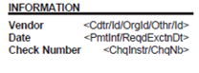  If Vendor = NONVEND  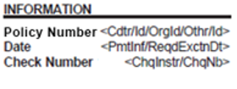  If Vendor = CUSTTABLE  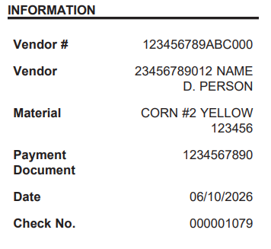  Where:  Value Field  Vendor # <Cdtr/Id/OrgId/Othr/Id>  Vendor <PmtInf/CdtTrfTxInf/RmtInf/Strd/AddtlRmtInf> <AddtlRmtInf> is a semi colon delimited line. Vendor name is the first field.  Material <PmtInf/CdtTrfTxInf/RmtInf/Strd/AddtlRmtInf> <AddtlRmtInf> is a semi colon delimited line. Material is the second field.  Payment Document <PmtInf/CdtTrfTxInf/RmtInf/Strd/AddtlRmtInf> <AddtlRmtInf> is a semi colon delimited line. Payment Document is the third field.  Date <PmtInf/ReqdExctnDt>  Check No. <ChqInstr/ChqNb>
R27001 | Rule to choose between Multiple complex segment remittance tables  Default table type = OPTION 1  Holland account 7 row table = OPTION 2  Pilgrims Pride Corp delimited table = OPTION 3
R27002 | Create rule for cashier’s check verbiage to appear. If the void_text does not equal CASHIER”S CHECK. Rule will be called Cashier’s Check and will be applied to both tables OPTION 1 and OPTION 2 to suppress them when this value is CASHEIR’S CHECK.
R27003 | XML will have the void text box to display the verbiage for Cashier’s check or amount of days, depending on the rule.
R27004 | Account Managers will be able to add the the verbiage CASHIER’S CHECK in the void after box in encompass and the PO XML will be come out as <Void_Text>CASHIER’S CHECK</Void_Text> , or can be used to show Void after # of days.  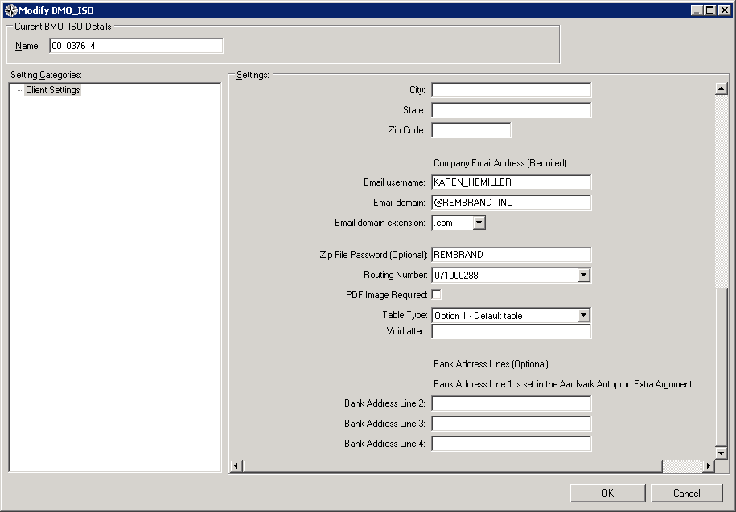

Appendix A – BMO/PO Data Mapping
Data Mapping
BMO XPATH | PUBLISHER ONLINE XPATH | DATA TYPE
CORRESPONDENCE DETAILS
 | CCS/Pack/CorrespondenceDetails/Correspondence_Pack_Id | Value = "ISO_Checks”
 | CCS/Pack/CorrespondenceDetails/Group | Value = "145BM_BMO-US”
 | CCS/Pack/CorrespondenceDetails/Product | Value =  “145BM_Checks”
PAYER DETAILS
/Document/CstmrCdtTrfInitn/PmtInf/PmtInfId | CCS/Pack/Payer/TransactionID | xs:string
/Document/CstmrCdtTrfInitn/PmtInf/CdtTrfTxInf/Cdtr/Id/OrgId/Othr/Id> | CCS/Pack/Payer/Vendor_ID | xs:string
Based on the client data file name | CCS/Pack/Payer/Vendor | xs:string if file name says VEND in this location P.COMSHARUS.[Customer ID].PAIN001.VEND.YYYYMMDD.HHMMSS.NXXXXXX.xml then the value equals VEND  if file name says NONVEND in this location P.COMSHARUS.[Customer ID].PAIN001.NONVEND.YYYYMMDD.HHMMSS.NXXXXXX.xml then the value equals NONVEND  if file name says CUSTTABLE in this location P.COMSHARUS.[Customer ID].PAIN001. CUSTTABLE.YYYYMMDD.HHMMSS.NXXXXXX.xml then the value equals CUSTTABLE  If neither of the above then still create the vendor field but leave blank
Take value from encompass field Table_Type | CCS/Pack/Remittance_Advice/Remittance_Table_Type | xs:string
Document/CstmrCdtTrfInitn/PmtInf/CdtTrfTxInf/ChqInstr/DlvryMtd/Prtry | CCS/Pack/Payer/Special_Handling_Code | xs:string
/Document/CstmrCdtTrfInitn/PmtInf/Dbtr/Nm | CCS/Pack/Payer/Name | xs:string
/Document/CstmrCdtTrfInitn/PmtInf/Dbtr/PstlAdr/BldgNb | CCS/Pack/Payer/Address_1 | xs:string  Concatenate each data field into one xpath
/Document/CstmrCdtTrfInitn/PmtInf/Dbtr/PstlAdr/StrtNm
/Document/CstmrCdtTrfInitn/PmtInf/Dbtr/PstlAdr/TwnNm | CCS/Pack/Payer/City | xs:string
/Document/CstmrCdtTrfInitn/PmtInf/Dbtr/PstlAdr/PstCd | CCS/Pack/Payer/Zip | xs:string
Document/CstmrCdtTrfInitn/PmtInf/Dbtr/PstlAdr/CtrySubDvsn | CCS/Pack/Payer/State | xs:string
enCompass 2>Commercial>BMO>ISO Check Clients>Account Number>Special Handling Address>Name | CCS/Pack/Payer/Special_Handling_Address/Name | xs:string
enCompass 2>Commercial>BMO>ISO Check Clients>Account Number>Special Handling Address>Attn: | CCS/Pack/Payer/Special_Handling_Address/Attention | xs:string
enCompass 2>Commercial>BMO>ISO Check Clients>Account Number>Special Handling Address>Street Address | CCS/Pack/Payer/Special_Handling_Address/Address | xs:string
enCompass 2>Commercial>BMO>ISO Check Clients>Account Number>Special Handling Address>City | CCS/Pack/Payer/Special_Handling_Address/City | xs:string
enCompass 2>Commercial>BMO>ISO Check Clients>Account Number>Special Handling Address>State | CCS/Pack/Payer/Special_Handling_Address/State | xs:string
enCompass 2>Commercial>BMO>ISO Check Clients>Account Number>Special Handling Address>Zip Code | CCS/Pack/Payer/Special_Handling_Address/Zip_Code | xs:string
enCompass 2>Commercial>BMO>ISO Check Clients>Account Number>Company Email Address>Email Username | CCS/Pack/Payer/Company_Email_Address | xs:string  Concatenate each field into one xpath
enCompass 2>Commercial>BMO>ISO Check Clients>Account Number>Company Email Address>Domain
enCompass 2>Commercial>BMO>ISO Check Clients>Account Number>Company Email Address>Domain Extension
enCompass 2>Commercial>BMO>ISO Check Clients>Account Number>Zip File Password | CCS/Pack/Payer/Zip_File_Password | xs:string
ADDRESSEE DETAILS
/Document/CstmrCdtTrfInitn/PmtInf/CdtTrfTxInf/Cdtr/Nm | CCS/Pack/Addressee/Address_Line_1 | xs:string
/Document/CstmrCdtTrfInitn/PmtInf/CdtTrfTxInf/Cdtr/PstlAdr/BldgNb | CCS/Pack/Addressee/Address_Line_2 | xs:string  Concatenate each data field into one xpath  Data pulling from the the BldgNb field is optional, not required. If BldgNb data is missing, include only the StrtNm field here.
/Document/CstmrCdtTrfInitn/PmtInf/CdtTrfTxInf/Cdtr/PstlAdr/StrtNm
/Document/CstmrCdtTrfInitn/PmtInf/CdtTrfTxInf/Cdtr/PstlAdr/TwnNm | CCS/Pack/Addressee/City | xs:string
/Document/CstmrCdtTrfInitn/PmtInf/CdtTrfTxInf/Cdtr/PstlAdr/PstCd | CCS/Pack/Addressee/ZipCode | xs:string
/Document/CstmrCdtTrfInitn/PmtInf/CdtTrfTxInf/Cdtr/PstlAdr/CtrySubDvsn | CCS/Pack/Addressee/State | xs:string
/Document/CstmrCdtTrfInitn/PmtInf/CdtTrfTxInf/Cdtr/PstlAdr/Ctry | CCS/Pack/Addressee/Country | Only populate when value is not “US”  For non-‘US’ values, convert the two character country code to full country name.  xs:string
REMITTANCE ADVICE DETAILS
/Document/CstmrCdtTrfInitn/PmtInf/CdtTrfTxInf/RmtInf/Ustrd [0…1] | CCS/Pack/Remittance_Advice/Remittance_Info/Remittance_Details | xs:string  There may be multiple occurrences of /Document/CstmrCdtTrfInitn/PmtInf/CdtTrfTxInf/RmtInf/Ustrd [0…1] from the client input file, which should result in the equal number of CCS/Pack/Remittance_Advice/Remittance_Info/Remittance_Details fields within a record in the XML file.
/Document/CstmrCdtTrfInitn/PmtInf/CdtTrfTxInf/RmtInf/Strd/RfrdDocInf/Nb [0…n] | CCS/Pack/Remittance_Advice/Remittance_Table/Remittance_Row/Ref_Number | xs:string
/Document/CstmrCdtTrfInitn/PmtInf/CdtTrfTxInf/RmtInf/Strd/RfrdDocInf/RltdDt [0…n] | CCS/Pack/Remittance_Advice/Remittance_Table/Remittance_Row/Ref_Date | xs:date
/Document/CstmrCdtTrfInitn/PmtInf/CdtTrfTxInf/RmtInf/Strd/RfrdDocAmt/DuePyblAmt [0…n] | CCS/Pack/Remittance_Advice/Remittance_Table/Remittance_Row/Doc_Amount | xs:decimal
/Document/CstmrCdtTrfInitn/PmtInf/CdtTrfTxInf/RmtInf/Strd/RfrdDocAmt/DscntApldAmt [0…n] | CCS/Pack/Remittance_Advice/Remittance_Table/Remittance_Row/Disc_Amount | xs:decimal
/Document/CstmrCdtTrfInitn/PmtInf/CdtTrfTxInf/RmtInf/Strd/RfrdDocAmt/RmtdAmt [0…n] | CCS/Pack/Remittance_Advice/Remittance_Table/Remittance_Row/Net_Amount | xs:decimal  Map If xpath CCS/Pack/Remittance_Advice/Remittance_Table/Invoice_Type equals ‘CINV’
/Document/CstmrCdtTrfInitn/PmtInf/CdtTrfTxInf/RmtInf/Strd/RfrdDocAmt/CdtNoteAmt [0…n] | CCS/Pack/Remittance_Advice/Remittance_Table/Remittance_Row/Net_Amount | xs:decimal  Map If xpath CCS/Pack/Remittance_Advice/Remittance_Table/Invoice_Type equals ‘CREN’
/Document/CstmrCdtTrfInitn/PmtInf/CdtTrfTxInf/RmtInf/Strd/RfrdDocInf/Tp/CdOrPrtry/Cd [0…n] | CCS/Pack/Remittance_Advice/Remittance_Table/Remittance_Row/Invoice_Type | xs:string
/Document/CstmrCdtTrfInitn/PmtInf/CdtTrfTxInf/RmtInf/Strd/AddtlRmtInf [0…n] | CCS/Pack/Remittance_Advice/Remittance_Table/Remittance_Row/Invoice_Details | xs:string
/Document/CstmrCdtTrfInitn/PmtInf/CdtTrfTxInf/RmtInf/Strd/AddtlRmtInf [0…n] | CCS/Pack/Remittance_Advice/Remittance_Table/Remittance_Row/Additional_Info | xs:string
CHECK DETAILS
Document/CstmrCdtTrfInitn/PmtInf/CdtTrfTxInf/Amt/InstdAmt | CCS/Pack/Check_Data/Check_Amount | xs:decimal
Document/CstmrCdtTrfInitn/PmtInf/CdtTrfTxInf/ChqInstr/ChqNb | CCS/Pack/Check_Data/Check_Number | xs:integer  If xpath: CCS/Pack/Check_Data/Routing_Number is ‘071000288’ or ‘071915580’, if string is less than 9 characters, pad with spaces.  If xpath: CCS/Pack/Check_Data/Routing_Number is ‘071025661’, if string is less than 8 characters, pad with spaces.
Document/CstmrCdtTrfInitn/PmtInf/ReqdExctnDt | CCS/Pack/Check_Data/Check_Date | xs:date
Document/CstmrCdtTrfInitn/PmtInf/CdtTrfTxInf/ChqInstr/MemoFld | CCS/Pack/Check_Data/Memo | xs:string  If there is a second occurrence of Document/CstmrCdtTrfInitn/PmtInf/CdtTrfTxInf/ChqInstr/MemoFld, in the client’s input file, then  concatenate each CCS/Pack/Check_Data/Memo field by adding a space between the values into one CCS/Pack/Check_Data/Memo field.  If there are any additional occurrences of Document/CstmrCdtTrfInitn/PmtInf/CdtTrfTxInf/ChqInstr/MemoFld after a second one, they are to be ignored.  If there are 0 occurrences of Document/CstmrCdtTrfInitn/PmtInf/CdtTrfTxInf/ChqInstr/MemoFld in the client’s input file, then omit the phrase: “Memo:” from the check.
Document/CstmrCdtTrfInitn/PmtInf/DbtrAcct/Id/Othr/Id | CCS/Pack/Check_Data/Account_Number | xs:integer  If xpath: CCS/Pack/Check_Data/Routing_Number is ‘071915580’, if string is less than 7 characters, pad with spaces.  If xpath: CCS/Pack/Check_Data/Routing_Number is ‘071000288’ or ‘071025661’, if string is less than 10 characters, pad with spaces.
Document/CstmrCdtTrfInitn/PmtInf/DbtrAgt/FinInstnId/ClrSysMmbId/MmbId | CCS/Pack/Check_Data/Routing_Number | xs:integer
/Document/CstmrCdtTrfInitn/PmtInf/CdtTrfTxInf/Cdtr/Nm | CCS/Pack/Check_Data/Payee/Payee_Line_1 | xs:string
/Document/CstmrCdtTrfInitn/PmtInf/CdtTrfTxInf/Cdtr/PstlAdr/ BldgNb | CCS/Pack/Check_Data/Payee/Payee_Line_2 | xs:string  Concatenate each data field into one xpath  Data pulling from the the BldgNb field is optional, not required. If BldgNb data is missing, include only the StrtNm field here.
/Document/CstmrCdtTrfInitn/PmtInf/CdtTrfTxInf/Cdtr/PstlAdr/ StrtNm
/Document/CstmrCdtTrfInitn/PmtInf/CdtTrfTxInf/Cdtr/PstlAdr/TwnNm | CCS/Pack/Check_Data/Payee/Payee_Line_3 | xs:string  Concatenate each data field into one xpath
/Document/CstmrCdtTrfInitn/PmtInf/CdtTrfTxInf/Cdtr/PstlAdr/PstCd
/Document/CstmrCdtTrfInitn/PmtInf/CdtTrfTxInf/Cdtr/PstlAdr/CtrySubDvsn
enCompass 2>Commercial>BMO>ISO Check Clients> Void text | CCS/Pack/Check_Data/Void_Text | xs:string  Depending on account it could say Void after 60 days or Void After 90 days  If neither of the above then still create the field but leave blank
enCompass 2>Commercial>BMO>ISO Check Clients>Property state | CCS/Pack/Check_Data/Bank_Address | Prepend “BMO NA|”to the value of bank_address  example; BMO NA|Washington  If bank address 1, 2, 3 and 4 are empty we will use the bank details
FILE INFORMATION
<Input File Name> | CCS/Pack/File_Information/File_Name | xs:string
enCompass 2>Commercial>BMO>ISO Check Clients>Account Number>Company Name | CCS/Pack/File_Information/Company_Name | xs:string
Document/CstmrCdtTrfInitn/GrpHdr/NbOfTxs | CCS/Pack/File_Information/Number_of_Checks | xs:intiger
Document/CstmrCdtTrfInitn/GrpHdr/CtrlSum | CCS/Pack/File_Information/Check_Total | xs:decimal
enCompass 2>Commercial>BMO>ISO Check Clients>Account Number>Courier Information>Courier Option | CCS/Pack/File_Information/Courier_Information/Courier_Option | xs:string  Do not populate if CCS/Pack/Payer/Special_Handling_Code is nil
enCompass 2>Commercial>BMO>ISO Check Clients>Account Number>Courier Information>Account Number | CCS/Pack/File_Information/Courier_Information/Account_Number | xs:string  Do not populate if CCS/Pack/Payer/Special_Handling_Code is nil
enCompass 2>Commercial>BMO>ISO Check Clients>Account Number>Courier Information>Bill to Name | CCS/Pack/File_Information/Courier_Information/Bill_to_Name | xs:string  Do not populate if CCS/Pack/Payer/Special_Handling_Code is nil
enCompass 2>Commercial>BMO>ISO Check Clients>Account Number>Courier Information>Bill to Address>Street Address | CCS/Pack/File_Information/Courier_Information/Bill_to_Address/Street_Address | xs:string  Do not populate if CCS/Pack/Payer/Special_Handling_Code is nil
enCompass 2>Commercial>BMO>ISO Check Clients>Account Number>Courier Information>Bill to Address>City | CCS/Pack/File_Information/Courier_Information/Bill_to_Address/City | xs:string  Do not populate if CCS/Pack/Payer/Special_Handling_Code is nil
enCompass 2>Commercial>BMO>ISO Check Clients>Account Number>Courier Information>Bill to Address>State | CCS/Pack/File_Information/Courier_Information/Bill_to_Address/State | xs:string  Do not populate if CCS/Pack/Payer/Special_Handling_Code is nil
enCompass 2>Commercial>BMO>ISO Check Clients>Account Number>Courier Information>Bill to Address>Zip Code | CCS/Pack/File_Information/Courier_Information/Bill_to_Address/Zip_Code | xs:string  Do not populate if CCS/Pack/Payer/Special_Handling_Code is nil

Appendix B – Mockup
If client file is P.COMSHARUS.[Customer ID].PAIN001.YYYYMMDD.HHMMSS.NXXXXXX.xml, then the check layout will look like the below

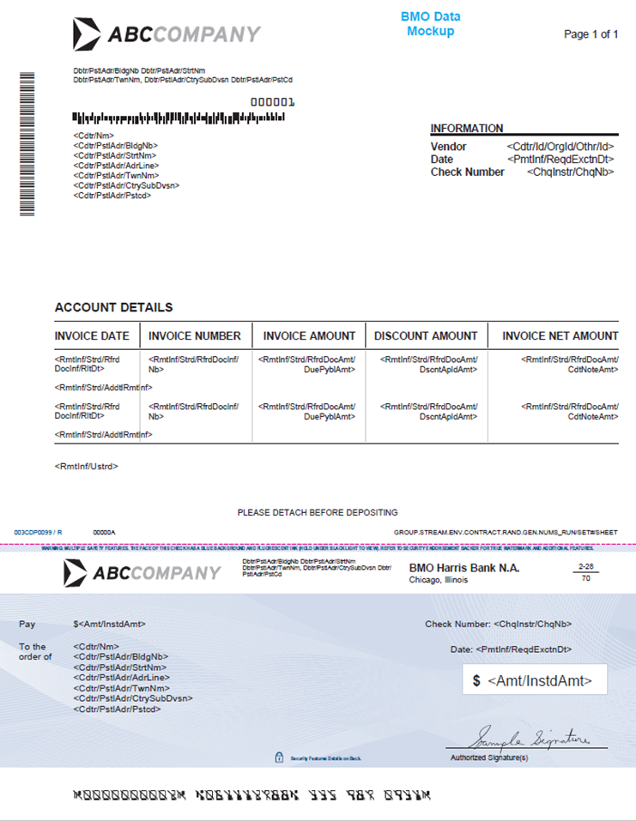
Additional details on reverse

If client file is P.COMSHARUS.[Customer ID].PAIN001.VEND.YYYYMMDD.HHMMSS.NXXXXXX.xml, then the check layout will look like the below.

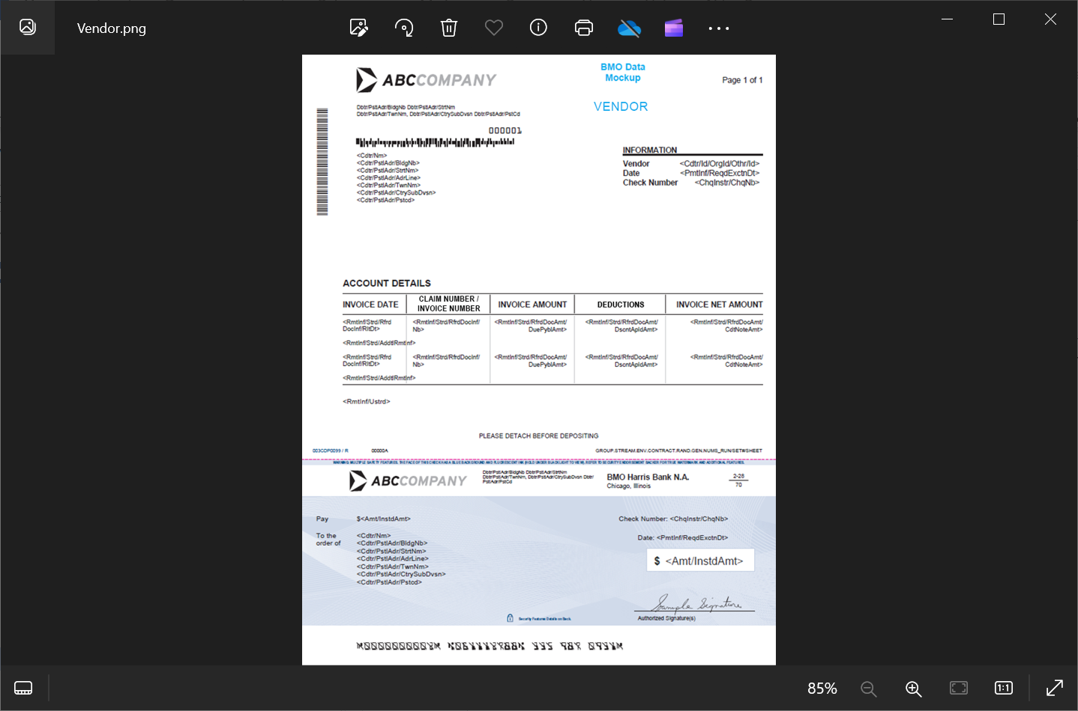
Additional details on reverse
If client file is P.COMSHARUS.[Customer ID].PAIN001.NONVEND.YYYYMMDD.HHMMSS.NXXXXXX.xml, then the check layout will look like the below

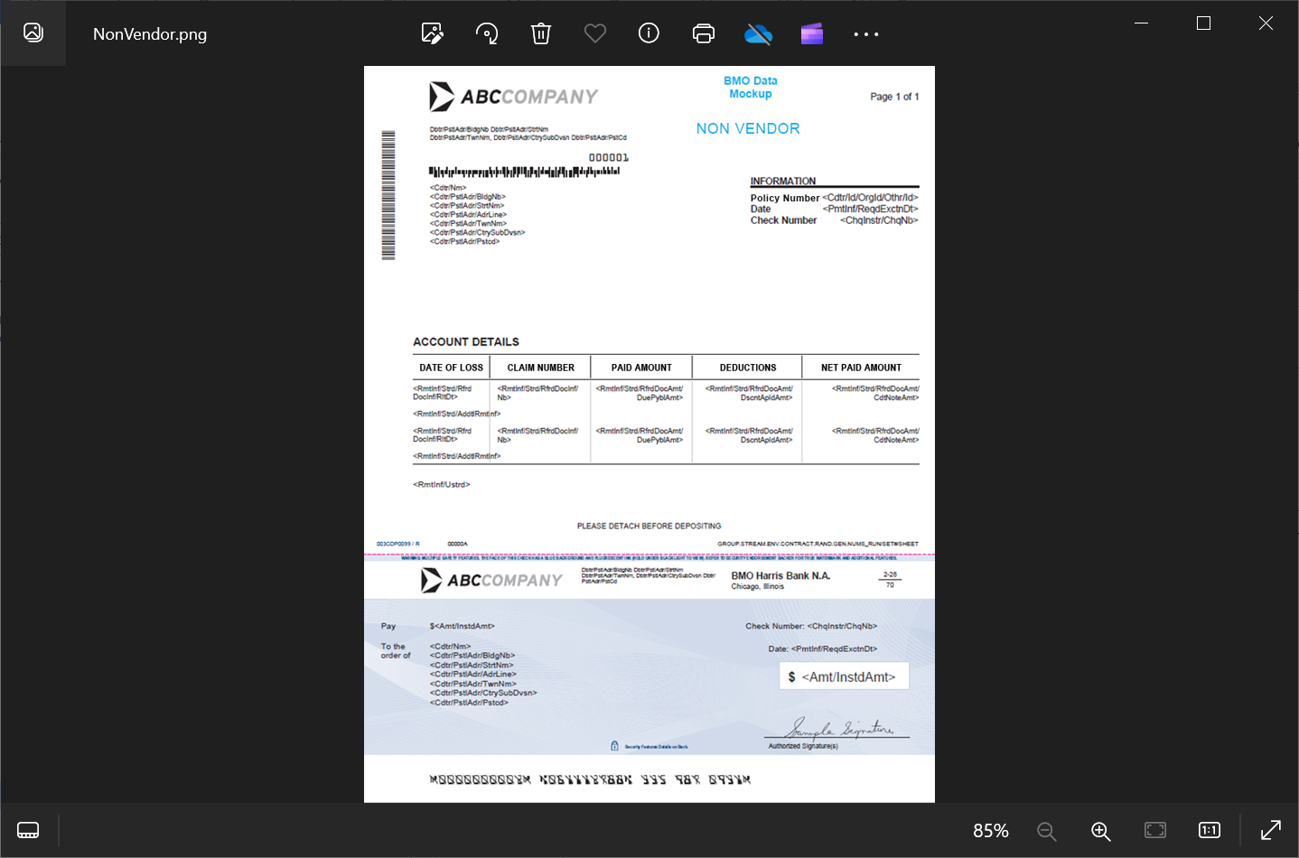
Additional details on reverse
For Holland accounts using Table Type Option 2 then the check layout will look like the below.
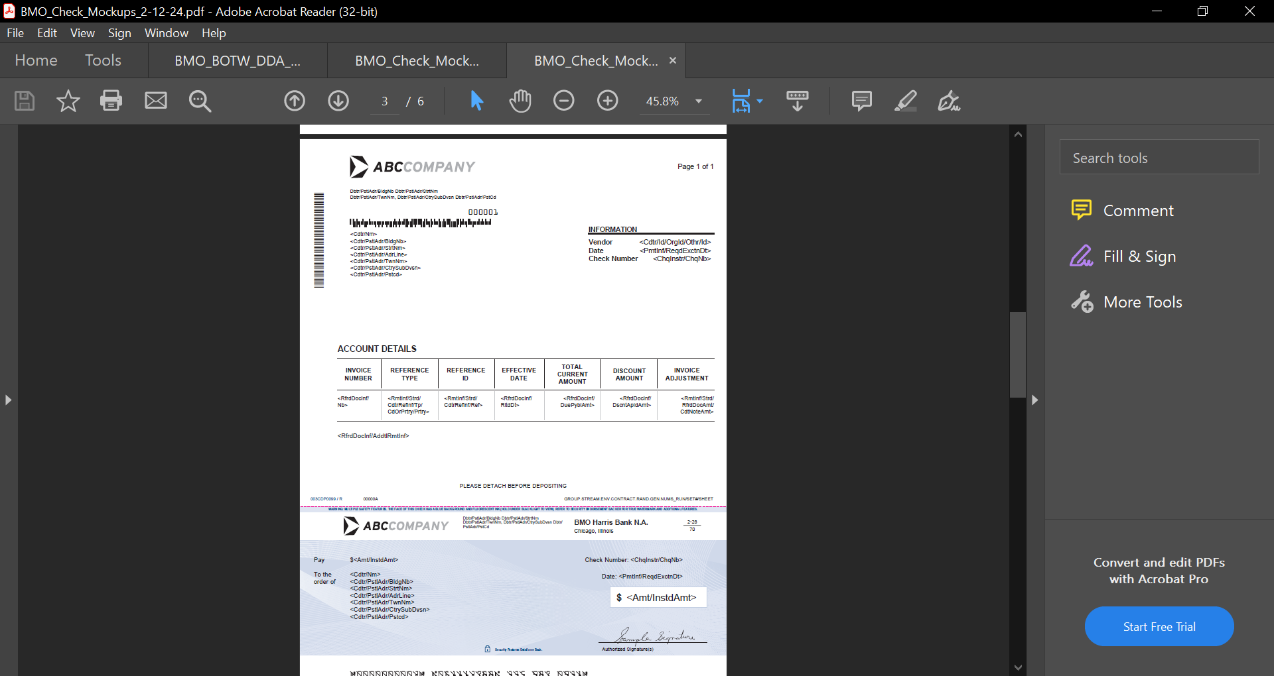
Additional details on reverse
For Pilgrim’s Pride Corp accounts using Table Type Option 3 then the check layout will look like the below.
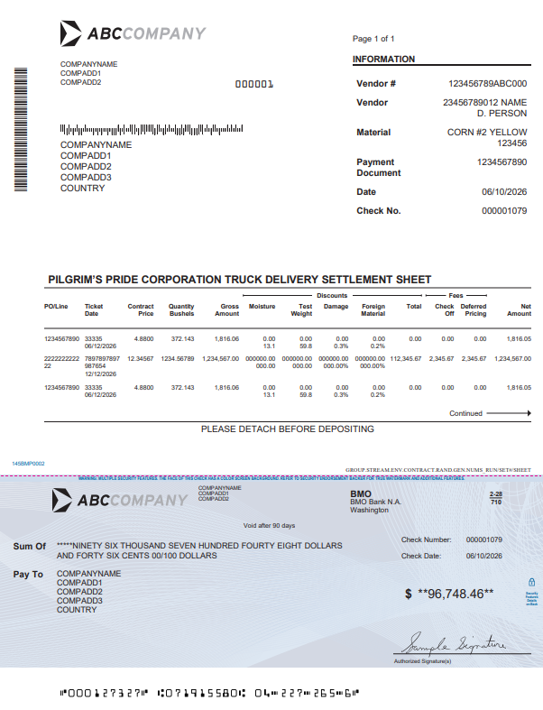

Appendix C – Mockup with PO Mappings
Additional details on reverse

Appendix D - REJECT REASON CODES
File Level Validations
Business Condition | Action | Reason Code | Definition of Reason Code | BMO XPATH(S)
File contains zero transactions | Fail the entire file | TD03 | File contains no transactions
Control Sum does not equal the total sum of all check in the file | Fail the entire file | AM10 | The total dollar amount not does not match the total dollar amount of all cheques processed.  The control sum is in this input field:  Document/CstmrCdtTrfInitn/GrpHdr/CtrlSum | /Document/CstmrCdtTrfInitn/GrpHdr/CtrlSum

Payment Info Group Level Validations
Business Condition | Action | Reason Code | Definition of Reason Code | BMO XPATH(S)
Payer Name is missing | Reject all transactions in the Payment Info Group with the same Reason Code and Additional Info, and continue processing the rest of the Payment Info Groups | CH21 | Mandatory Payer Detail Field is Missing: Payer Name, Data mapping at right from Payer Details in Appendix A | /Document/CstmrCdtTrfInitn/PmtInf/Dbtr/Nm
Payer Street Name is missing | Reject all transactions in the Payment Info Group with the same Reason Code and Additional Info, and continue processing the rest of the Payment Info Groups | CH21 | Mandatory Payer Detail Field is Missing:  Payer Street Name  Data mapping at right from Payer Details in Appendix A | /Document/CstmrCdtTrfInitn/PmtInf/Dbtr/PstlAdr/StrtNm
Payer City is missing | Reject all transactions in the Payment Info Group with the same Reason Code and Additional Info, and continue processing the rest of the Payment Info Groups | CH21 | Mandatory Payer Detail Field is Missing: City  Data mapping at right from Payer Details in Appendix A | /Document/CstmrCdtTrfInitn/PmtInf/Dbtr/PstlAdr/TwnNm
Payer State is missing | Reject all transactions in the Payment Info Group with the same Reason Code and Additional Info, and continue processing the rest of the Payment Info Groups | CH21 | Mandatory Payer Detail Field is Missing: State  Data mapping at right from Payer Details in Appendix A | Document/CstmrCdtTrfInitn/PmtInf/Dbtr/PstlAdr/CtrySubDvsn
Payer Zip is missing | Reject all transactions in the Payment Info Group with the same Reason Code and Additional Info, and continue processing the rest of the Payment Info Groups | CH21 | Mandatory Payer Detail Field is Missing: Zip  Data mapping at right from Payer Details in Appendix A | Document/CstmrCdtTrfInitn/PmtInf/Dbtr/PstlAdr/PstCd
Account Number is Missing | Reject all transactions in the Payment Info Group with the same Reason Code and Additional Info, and continue processing the rest of the Payment Info Groups | CH21 | Mandatory Check Detail Field is Missing: Account Number  OR  Account Number is not found in Encompass2 | Document/CstmrCdtTrfInitn/PmtInf/DbtrAcct/Id/Othr/Id
Routing Number is Missing | Reject all transactions in the Payment Info Group with the same Reason Code and Additional Info, and continue processing the rest of the Payment Info Groups | CH21 | Mandatory Check Detail Field is Missing:  Routing Number | Document/CstmrCdtTrfInitn/PmtInf/DbtrAgt/FinInstnId/ClrSysMmbId/MmbId
Transit [Routing] Numbers/ MICR Details invalid | Reject all transactions in the Payment Info Group with the same Reason Code and Additional Info, and continue processing the rest of the Payment Info Groups | NARR | Routing number is not found in our routing number database nor in Encompass2 for the Account Number passed to us in the Pain001 file. | Document/CstmrCdtTrfInitn/PmtInf/DbtrAgt/FinInstnId/ClrSysMmbId/MmbId

Transaction Level Validations
Business Condition | Action | Reason Code | Definition of Reason Code | BMO XPATH(S)
Payee Name is missing | Skip the record, continue processing the rest of the file | CH21 | Mandatory Payee Detail Field is Missing: Payee Name, Data mapping at right from Check Details in Appendix A | /Document/CstmrCdtTrfInitn/PmtInf/CdtTrfTxInf/Cdtr/Nm
Payee Street Name or Address Line is missing | Skip the record, continue processing the rest of the file | CH21 | Mandatory Payee Detail Field is Missing: Street Name AND Address Line  Data mapping at right from Check Details in Appendix A | /Document/CstmrCdtTrfInitn/PmtInf/CdtTrfTxInf/Cdtr/PstlAdr/ StrtNm  /Document/CstmrCdtTrfInitn/PmtInf/CdtTrfTxInf/Cdtr/PstlAdr/AdrLine
Payee City is missing | Skip the record, continue processing the rest of the file | CH21 | Mandatory Payee Detail Field is Missing: City  Data mapping at right from Check Details in Appendix A | /Document/CstmrCdtTrfInitn/PmtInf/CdtTrfTxInf/Cdtr/PstlAdr/TwnNm
Payee State is missing | Skip the record, continue processing the rest of the file | CH21 | Mandatory Payee Detail Field is Missing: State  Data mapping at right from Check Details in Appendix A | /Document/CstmrCdtTrfInitn/PmtInf/CdtTrfTxInf/Cdtr/PstlAdr/CtrySubDvsn
Payee Zip is missing | Skip the record, continue processing the rest of the file | CH21 | Mandatory Payee Detail Field is Missing: ZIP  Data mapping at right from Check Details in Appendix A | /Document/CstmrCdtTrfInitn/PmtInf/CdtTrfTxInf/Cdtr/PstlAdr/PstCd
Check Number is missing | Skip the record, continue processing the rest of the file | CH21 | Mandatory Check Detail Field is Missing: Check Amount, Check Date; Data mapping at right from Check Details in Appendix A | Document/CstmrCdtTrfInitn/PmtInf/CdtTrfTxInf/ChqInstr/ChqNb
Check Amount is missing | Skip the record, continue processing the rest of the file | CH21 | Mandatory Check Detail Field is Missing: Check Amount  Data mapping at right from Check Details in Appendix A | Document/CstmrCdtTrfInitn/PmtInf/CdtTrfTxInf/Amt/InstdAmt
Check Date is missing | Skip the record, continue processing the rest of the file | CH21 | Mandatory Check Detail Field is Missing: Check Date  Data mapping at right from Check Details in Appendix A | Document/CstmrCdtTrfInitn/PmtInf/ReqdExctnDt
Cheque Number exceeds 10 digits | Skip the record, continue processing the rest of the file | NARR | Data exceeds the maximum character limit required. | Document/CstmrCdtTrfInitn/PmtInf/CdtTrfTxInf/ChqInstr/ChqNb
Cheque Number is not numeric | Skip the record, continue processing the rest of the file | FF09 | If the cheque number is not numeric, an error is produced. | Document/CstmrCdtTrfInitn/PmtInf/CdtTrfTxInf/ChqInstr/ChqNb
Memo Field -Max character limited exceeded | Skip the record, continue processing the rest of the file | NARR | Max 35 characters per field; 2 field occurrences allowed.  Data exceeds the maximum character limit required for one or both field occurences. | Document/CstmrCdtTrfInitn/PmtInf/CdtTrfTxInf/ChqInstr/MemoFld
Cheque Amount is 0 or negative value | Skip the record, continue processing the rest of the file | AM12 | If the cheque amount equals 0 or a negative value. | Document/CstmrCdtTrfInitn/PmtInf/CdtTrfTxInf/Amt/InstdAmt
Currency not in USD | Skip the record, continue processing the rest of the file | CURR | Currency of the payment is not in USD | N/A
Duplicate check found within the input file | Skip the record, continue processing the rest of the file | DUPL | If a duplicate cheque number is passed, this error will be generated. Check against the duplicate check database. | Document/CstmrCdtTrfInitn/PmtInf/CdtTrfTxInf/ChqInstr/ChqNb
Duplicate cheque found: '$set->{'BR.ChequeNumber'}' was already processed (within last year) in data file | Skip the record, continue processing the rest of the file | DUPL | If a duplicate cheque number is passed, this error will be generated. Check against the duplicate check database. | Document/CstmrCdtTrfInitn/PmtInf/CdtTrfTxInf/ChqInstr/ChqNb

